Small Modular Reactors
MTE4593 Assignment 2
Where small modular reactors cut the most carbon, what holds them back, and a low-clinker concrete initiative for Darlington
Authors: Leroy Louis Jean (33880212), Sam [surname] ([student ID]), Victor Clarke ([student ID])
Date of Submission: 25 October 2026

Abstract
Small modular reactors (SMRs) are proposed to replace closing coal plants. This report asks whether an SMR is feasible across the triple bottom line, and whether a materials choice can cut its footprint without delaying it. We study the GE Vernova Hitachi BWRX-300 (300 MWe) at Darlington, Ontario, and compare Liddell, New South Wales, a closed coal site.
Our initiative, C1, is low-clinker concrete for the steel-composite infill and forebay shaft of Darlington Units 2–4: pilot limestone calcined clay cement (LC³) in eligible non-safety works first, extend it to the infill only if qualified, and adopt it only if schedule-neutral. A screening life-cycle assessment (ISO 14040/44 principles) gives about 4 g CO₂e/kWh for one unit, mostly from the fuel front end. C1 saves about 2,200 t per unit (1,100–3,300), about 0.36% of the life cycle, and a delay of about 12–18 days cancels it.
Law, cost and timing decide the Australian case. An SMR at Liddell could not start before about 2040, and firmed renewables avoid 10.9 times more CO₂e per dollar. In a multi-criteria analysis, renewables rank first under all four weight sets.
We recommend piloting LC³ in eligible non-safety works first, and extending it to the infill only if qualified on Unit 1 mock-ups. In Australia, we recommend firmed renewables.

Table of Contents
Abstract 1
Table of Contents 2
1 Introduction 3
2 Data Sources/Methodology 3
3 Discussion 4
3.1 Overview of SMR 4
3.2 Lifecycle Analysis 9
3.3 National Strategies and Industrial Policies: Carbon Avoided in Ontario and Australia 14
3.4 Stakeholder Analysis 16
3.5 Market Analysis and Economic Feasibility 20
3.6 Government Regulations Review 23
3.7 Triple-bottom-line evaluation and multi-criteria analysis 26
3.8 Future material properties and processes 28
4 Conclusion 29
5 References 31
Declaration of generative AI use 42
Appendices 43
Appendix A. LCA inventory and calculations 43
Appendix B. Policy, economics and supply calculations 45
Appendix C. Sensitivity analysis 48
Appendix E. Search log 50

1 Introduction
Small modular reactors (SMRs) are one proposed replacement for closing coal plants. We ask whether an SMR is feasible across the triple bottom line (environmental, economic, social), and whether a materials choice can make it cleaner without delaying it.
Liddell in New South Wales (NSW) has closed (Australian Energy Regulator, 2021), yet NSW’s grid still emits about 640 g CO₂e/kWh (Department of Climate Change, Energy, the Environment and Water [DCCEEW], 2025); Ontario’s emits about 74 (The Atmospheric Fund, 2025). An SMR is a reactor of up to about 300 MWe built largely from factory-made modules (International Atomic Energy Agency, 2024).
Darlington, Ontario is the initiative site: Ontario Power Generation (OPG) plans four BWRX-300 units for C$20.9 billion, Unit 1 in service in 2030 (Ontario Power Generation, 2025a). Liddell is the Australian comparison.
OPG should pilot limestone calcined clay cement (LC³) in eligible non-safety works first, using it in the steel-composite infill only if qualified and schedule-neutral (Sections 3.1.1–3.1.4, Section 3.1.5).
We answer four research questions.
- What does one BWRX-300 emit? (Section 3.2)
- How much does C1 save, and what delay cancels it? (Sections 3.2–3.3)
- Does a unit’s climate value differ between Ontario and Liddell? (Section 3.3)
- Which barriers decide, and does an SMR beat firmed renewables? (Section 3.1.3, Sections 3.4–3.7)

2 Data Sources/Methodology
Four methods carry the numbers: a screening life-cycle assessment (LCA), grid displacement with a schedule break-even, a concentration index for fuel supply, and a multi-criteria analysis. Scripts and parameter files regenerate every figure (Appendix A1). Values come from the documents cited; our assumptions and inferences are labelled.
A screening study following ISO 14040/14044 principles (International Organization for Standardization, 2006a; 2006b), not critically reviewed: functional unit 1 MWh of net electricity at the grid connection, cradle to grave (Section 3.2.1). A Granta EduPack cross-check was planned but not completed.
One unit (300 MWe net assumed) supplies 2.365 TWh a year and avoids that output × (grid factor − SMR factor). The average factor is the grid’s mean intensity; the marginal factor is that of the plant displaced (The Atmospheric Fund, 2025). Ontario’s are 73.8 and 343 g/kWh; NSW uses 640 (Department of Climate Change, Energy, the Environment and Water [DCCEEW], 2025). Start years are 2030 at Darlington (Ontario Power Generation, 2025a) and 2040 at the earliest in Australia (Graham, Hayward and Foster, 2024). The schedule break-even is the delay that cancels a saving S: S ÷ (daily output × grid-factor gap) (Appendix B4–B5).
The Herfindahl–Hirschman index (HHI) sums squared percentage market shares (0 to 10,000); above 1,800 is highly concentrated (US Department of Justice and Federal Trade Commission, 2023). Capacity is not contracts (Appendix B2).
A weighted sum (Dodgson et al., 2009) scores four options (status quo, one SMR at Liddell, the same SMR built with C1’s concrete, firmed renewables) on seven criteria, each min-max normalised. Four weight sets are our judgement; robustness is tested in Appendix B7.
Search strategy and patent search: Appendix E.

3 Discussion

3.1 Overview of SMR

3.1.1 Current Projects and Patents
No light-water SMR is yet reported operating on land; the BWRX-300 is the closest Western design, and China’s ACP100 (Linglong One) was still in commissioning, with no criticality reported, in May 2026. Table T1 rates projects on technology readiness levels (TRL): level 8 is “completed and qualified through test and demonstration”, level 9 operated across its full range (US Department of Energy, 2015); ratings are ours.
Table T1. Selected SMR-class projects, October 2026. Source: Canadian Nuclear Safety Commission (2025); Ontario Power Generation (2025b); American Nuclear Society (2026); GE Vernova (2026); World Nuclear News (2023); US Nuclear Regulatory Commission (2025); NuScale Power Corporation (2023); TRL ratings: this study. Status entries are as reported by regulators, vendors, utilities and trade press found by web search; we have not opened the primary documents.
Project | Design (MWe) | Status | First power | TRL
Darlington Unit 1, Ontario | BWRX-300 (300; 315 net) | Licence to construct April 2025 | October 2030 | 6–7
Darlington Units 2–4 | BWRX-300 (3 × 300) | In the C$20.9 bn budget but unlicensed; approval expected 2028 | After Unit 1 | 6–7
Clinch River, Tennessee | BWRX-300 (300) | NRC construction permit, 29 September 2026 | Not announced | 6–7
HTR-PM, Shandong | Pebble-bed (210) | Commercial operation December 2023 | Grid December 2021 | 8–9
Carbon Free Power Project, Idaho | NuScale (462) | Cancelled November 2023 | None | 6
Cost, not licensing, stopped NuScale. Its design was approved in May 2025, yet the first plant was cancelled when the estimate reached US$9.24 bn as reported, about US$20,000/kW (NuScale Power Corporation, 2023). Darlington’s C$20.9 bn for 1,200 MW is C$17,400/kW (Ontario Power Generation, 2025a; 2025b); both are first-of-a-kind, in different currencies. Darlington’s construction licence took about 29 months and Clinch River’s permit 14 (US Nuclear Regulatory Commission and Canadian Nuclear Safety Commission, 2025).
Appendix E, from search summaries only, found GE-Hitachi isolation-condenser patents but none on the diaphragm-plate composite modules, and no core LC³ composition patent, though Sika and Construction Research & Technology hold LC³ applications. This suggests, but does not establish, that C1’s binder risk lies in qualification rather than patents; no freedom-to-operate search was done.
Australia’s earliest date is about 2040. The Coalition’s 2024 plan claimed SMR power by 2035 (ABC News, 2024); CSIRO’s GenCost 2023-24 is reported to say 2040 at the earliest (Graham, Hayward and Foster, 2024). Darlington supports CSIRO: even with a licensed site, it needs about eight years from licence application (October 2022) to power (October 2030) (Canadian Nuclear Safety Commission, 2026a; Ontario Power Generation, 2025b). Australia must first repeal two federal bans (Section 3.6.1), assumed by 2029, and build a licensing regime, assumed to take three years: 2029 + 3 + 8 gives about 2040 (Section 3.3).

3.1.2 Technical Descriptions: the BWRX-300 at Darlington
The BWRX-300’s composite building is what C1 targets. The reactor is rated 300 MWe (GE Vernova Hitachi Nuclear Energy, n.d.; 315 MW net in Ontario Power Generation, 2025b), with a 60-year design life (Canadian Nuclear Safety Commission, 2024). The vendor-reported capacity factor is 95% (Fermi Energia, n.d.); we use 0.90. Passive isolation condensers cool the core for seven days (GE Hitachi Nuclear Energy, n.d.). The reactor building sits in a below-grade shaft of diaphragm-plate steel-composite (DP-SC) modules filled with self-consolidating concrete (SCC) (GE-Hitachi Nuclear Energy, 2024).
The vendor’s concrete claim is hard to reconcile with Ostrołęka. GE Vernova (n.d.) claims about half the concrete per MW of its larger ESBWR, yet Ostrołęka’s information sheet gives 50,000 m³ per unit, or 167 m³/MWe (BWRX-300 Ostrołęka sp. z o.o., 2023), against the ESBWR’s 69 (Peterson, Zhao and Petroski, 2005). The gap probably reflects the boundary (our inference); a small reactor does not mean small concrete (Section 3.1.4).

3.1.3 Barriers to cutting emissions with small modular reactors
Eight barriers decide whether a small modular reactor (SMR) is built and cuts emissions; C1 (Section 3.1.4) reaches one directly and is constrained by a second. At Darlington, Ontario, cost and schedule bind. At Liddell, the closed New South Wales coal plant we use as the Australian comparison, law comes first (Sections 3.4–3.6).
Table T2. Eight barriers to SMR deployment, and whether initiative C1 touches them. Source: as cited in each row; working in Appendix B.
Barrier | Number and source | Why it matters | Does C1 touch it?
1. Cost and finance | C$149–198/MWh (Ontario Power Generation, 2026b; this study); NuScale cancelled 2023 (Section 3.5.1) | Capital is 65–86% of cost | No
2. Time to deploy | Unit 1 in service 2030; 2040 at the earliest in Australia (Ontario Power Generation, 2025a; Graham, Hayward and Foster, 2024) | Late plants displace less CO₂e (Section 3.3) | Yes, as a constraint
3. Law | No more than 36–37 of the 39 Senate votes needed to repeal the federal bans (Parliament of Australia, 2026) | NSW’s own ban would remain | No
4. Fuel-supply concentration | Enrichment HHI 3,009 against 1,800 (World Nuclear Association, 2025; US Department of Justice and Federal Trade Commission, 2023) | Russia holds 41–43% (Section 3.5.2) | No
5. Embodied carbon and qualification | 11.5% of life-cycle emissions is construction; C1 saves 2,200 t per unit (Section 3.2) | Infill needs nuclear qualification (Section 3.6.1) | Yes: C1’s target
6. Social licence | 59% wanted the ban kept in 2024 (Griffith University Climate Action Beacon and Monash Climate Change Communication Research Hub, 2025) | No consent route (Section 3.4.2) | No
7. Workforce | AUKUS submarine work competes for the same trades (Joint Standing Committee on Treaties, 2024) | Scarce trades (Section 3.4.2) | No
8. Waste | C$26 bn Canadian repository, producer-funded; no Australian route (Nuclear Waste Management Organization, n.d.) | Needs a disposal route (Section 3.4.2) | No

3.1.4 The initiative: low-clinker concrete for the Darlington Units 2–4 infill
C1 targets a materials problem that modular construction creates, and it is worth doing only if it is schedule-neutral. The BWRX-300’s reactor building is made of diaphragm-plate steel-composite (DPSC) modules filled on site with concrete. The infill must flow between closely spaced plates, so we assume a cement-rich self-consolidating mix (our inference; GE-Hitachi Nuclear Energy, 2024). A delay of 11.6–18.5 days to one unit on Ontario’s average grid, or 1.7–1.8 days on its marginal grid, cancels that unit’s saving (Section 3.3.1).
Ontario Power Generation (OPG) should pilot limestone calcined clay cement (LC³; Scrivener et al., 2018) in eligible non-safety works first, and use it in the infill only if qualified on Unit 1 mock-ups; Units 2–4 need future licensing (Section 3.6.1, Section 3.6.2). The Ostrołęka BWRX-300 design uses 50,000 m³ of concrete per unit (BWRX-300 Ostrołęka sp. z o.o., 2023). If 20%, 40% or 60% is eligible, replacing ordinary cement with LC³ (380 to 270 kg CO₂e/m³; Pillai et al., 2019) saves 1,100, 2,200 or 3,300 t CO₂e per unit (40% central), and 6,600 t across Units 2–4. A qualified slag blend is the fallback.
Table T3. Initiative C1: location, scale, application, technology, saving and condition. Source: this study, Section 3.2.3; sources as cited in the cells.
Element | Specification
Location | Darlington New Nuclear Project, Clarington, Ontario; Units 2–4
Scale | 50,000 m³ per unit; 20,000 m³ (40%) eligible
Application | Non-safety works first; DPSC infill if qualified
Technology | LC³ (270 against 380 kg CO₂e/m³); slag cement as fallback
Saving | 2,200 t per unit (1,100–3,300); 6,600 t for Units 2–4; about 0.36% of a unit’s life cycle
Condition | Schedule-neutral; infill qualified under topical report NEDO-33926 (GE-Hitachi Nuclear Energy, 2024; US Nuclear Regulatory Commission and CNSC, 2025)
Why it is not the obvious choice. C1’s value is set by schedule, not by the concrete: under three weeks of delay to a unit cancels its saving (Section 3.3.1), so C1 is a qualification programme timed to Unit 1 mock-ups. Its lever is financial: the Units 2–4 equity tranche can carry the condition (Section 3.6.2).
What C1 does not address. Cost, law, fuel supply, social licence and workforce (Table T2); lower-carbon steel is the next lever (Section 3.2.3, Section 3.8).

3.1.5 Materials from extraction to end-of-life
For C1, the binder’s carbon arises in the kiln, but its risks arise in the pour and at decommissioning. Stages follow Section 3.2.1’s boundary.
Table T4. C1 binder options from extraction to end-of-life. Source: as cited in the cells.
Stage | Portland clinker | LC³ | Slag
Extraction and processing | Limestone and shale kilned; M50 concrete 380 kg CO₂e/m³ (Pillai et al., 2019) | Clay calcined near 800 °C, half the clinker (Zunino, 2021); 270 kg CO₂e/m³ | Ground by-product; 146.6 kg CO₂e/t (Slag Cement Association, n.d.)
Construction | Reference mix | Lower flow in trials (Universität der Bundeswehr München, n.d.) | Lower heat in thick sections (Systematic evaluation of concrete placement reliability, 2026)
Service | Aggregate swelling, not the binder, dominates radiation damage (Field, Remec and Le Pape, 2015) | Same aggregates, similar risk (our inference); no heat data (Section 3.8) | Established
Decommissioning | Activated near the core (below) | Europium and cobalt unknown | Not assessed
Each unit uses 14,000 t (BWRX-300 Ostrołęka sp. z o.o., 2023). Blast-furnace steel emits about 2.33 t CO₂/t and scrap-based electric arc furnace (EAF) steel 0.68 (World Steel Association, 2026), but scrap copper embrittles vessel steel under irradiation, so nuclear plate is not a drop-in (Canadian Nuclear Safety Commission, 2023b).
Activation depends on trace elements: cobalt-60 and europium-152 dominate activated shield concrete (Helmholtz-Zentrum Dresden-Rossendorf, n.d.). Most decommissioning concrete is reportedly cleared, leaving “a few per cent” as waste (Thierfeldt, 2019); on an assumed 2.4 t/m³ and 2–5%, a unit’s 50,000 m³ (120,000 t) leaves 2,400–6,000 t. Qualification should measure calcined clay’s europium and cobalt (Section 3.8).

3.2 Lifecycle Analysis
One BWRX-300 at Darlington emits an estimated 4.4 g CO₂e per kWh (Monte Carlo median; 90% interval 3.2–6.1; 3.5 if conversion heat takes its central published value), below UNECE’s 5.1–6.4 g/kWh for nuclear power. The fuel front end contributes 62% and construction 11.5%. The initiative, C1 (Section 3.1.4), puts limestone calcined clay cement (LC³) in 20–60% of the concrete. It saves 2,200 t CO₂e per unit (1,100–3,300 t), about 0.36% of the life cycle: real but small, so worth adopting only if schedule-neutral (Section 3.2.3).

3.2.1 Goal, scope and method
This is a screening LCA of one BWRX-300 at Darlington following ISO 14040/14044 principles (International Organization for Standardization, 2006a; 2006b), not critically reviewed.
Functional unit: 1 MWh of net electricity at the grid connection. One unit delivers 300 MWe × 8,760 h × 0.90 × 60 years = 1.419 × 10⁸ MWh (Appendix A2). Boundary (Figure F1): cradle to grave. Construction materials and the fuel front end are modelled from published factors; operation and maintenance (O&M), decommissioning and the back end are per-kWh values from EDF’s French-fleet study (EDF R&D, 2024). Baseline (S0): the concrete OPG would pour anyway, at 380 kg CO₂e/m³ (Pillai et al., 2019, as reported). We have not seen OPG’s mix or any cement-type limit (GE-Hitachi Nuclear Energy, 2024). Cut-offs: fuel cladding, conversion chemicals, upstream gas, fuel-plant capital goods and recycling credits; each biases the result low (Section 3.2.5). Impact category: GWP100.
A reproducible Python model multiplies quantities by published emission factors (Appendices A and C). Plant quantities come from the Ostrołęka project information sheet (BWRX-300 Ostrołęka sp. z o.o., 2023, as reported): 50,000 m³ of concrete and 14,000 t of steel per unit, a design proxy, not confirmed Darlington quantities. A bottom-up scaling (20,700 m³; Peterson, Zhao and Petroski, 2005) is a cross-check (Appendix A3). A Granta EduPack Eco Audit was planned but not completed; no number here comes from Granta.
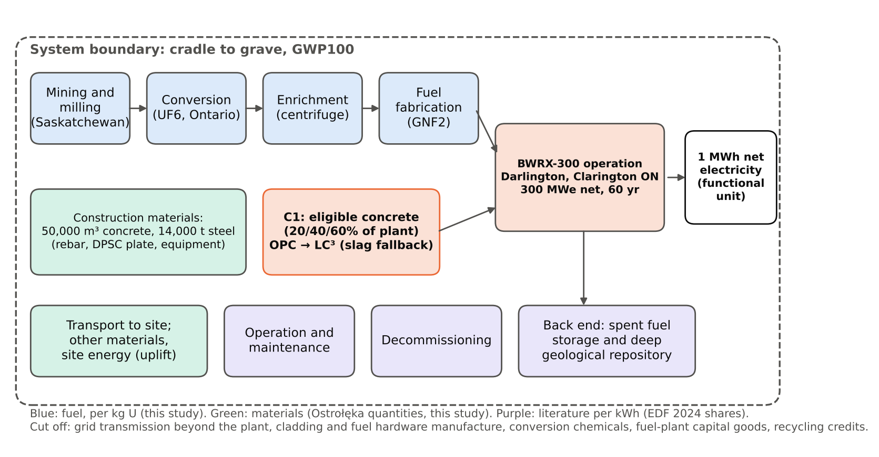
Figure F1. LCA system boundary for one BWRX-300 at Darlington: fuel front end, construction materials and C1-eligible concrete modelled here; operation, decommissioning and back end from the literature. | Source: this study.

3.2.2 Baseline and hotspots
One unit emits 4.40 g/kWh (median; 90% interval 3.24–6.05). With every input at its most likely value (the “mode case”) it is 2.86; Section 3.2.4 explains the gap. On the expected basis (Figure F2):
Mining and milling: 1.26 g/kWh (28%), low because Saskatchewan ores are high-grade (Parker, McNaughton and Sparrow, 2016). Conversion: 1.10 g/kWh (25%), an uncertainty hotspot: published heat demand spans 26–665 kWh per kg of uranium (Gibon and Hahn Menacho, 2023); at the most likely value it is only 0.13 g/kWh. Back end: 0.65 g/kWh (15%), transferred from France, which reprocesses; Canada plans direct disposal (Nuclear Waste Management Organization, 2024a), so this may be high.
The back end and decommissioning add 18%, O&M 9% and construction 11.5% (0.52 g/kWh). The C1-eligible concrete is only 1.9% of the mode-case total, so C1 acts on about one-fiftieth of the footprint. Ostrołęka’s 167 m³ per MWe is 2.4 times the ESBWR’s 69 (Peterson, Zhao and Petroski, 2005), so scale effects outweigh the vendor’s claim of 50% less concrete per unit of energy (GE Vernova, n.d.). The cross-check gives 4.20 g/kWh (Appendix A8).
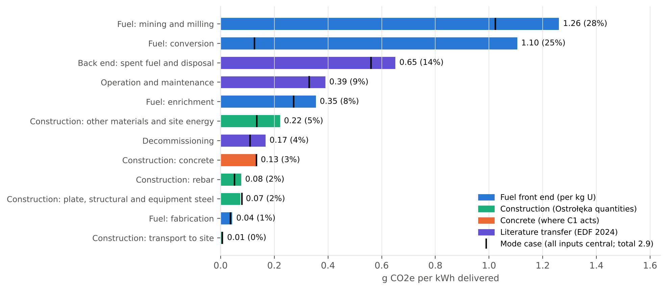
Figure F2. Life-cycle emissions of one BWRX-300 by stage: expected value 4.49 g CO₂e/kWh (Monte Carlo mean), with the mode case (every input at its most likely value, total 2.86) marked. | Source: this study, Appendix C3.

3.2.3 The initiative against the baseline
C1 is low-clinker concrete: LC³ on eligible non-safety works first and on the steel-composite infill only if qualified, a slag blend as the fallback, specified only if schedule-neutral (Section 3.1.4). Pillai et al. (2019, as reported) give 380 kg CO₂e/m³ for ordinary concrete and 270 for LC³, a cut of 110 kg/m³ (28.9%). The eligible share is our scenario, not data. At 20, 40 and 60% of 50,000 m³, C1 saves 1,100, 2,200 and 3,300 t per unit, or 0.18, 0.36 and 0.54% of its life cycle (Table T5). Varying eligibility, the cut and volumes together gives 2,217 t (1,375–3,294). Only Units 2–4 count, because Unit 1’s basemat is placed.
Table T5. C1 saving against the baseline, per unit and for Units 2–4; share of life cycle is the Monte Carlo median (5th–95th percentile). Source: this study, Appendices A6–A7 and C4.
Scenario | Per unit, t CO₂e | Units 2–4, t | Clinker avoided per unit, t | Share of life cycle
LC³ on 20% of plant concrete | 1,100 | 3,300 | 1,470 | 0.18% (0.11–0.28)
LC³ on 40% (central) | 2,200 | 6,600 | 2,940 | 0.36% (0.23–0.56)
LC³ on 60% | 3,300 | 9,900 | 4,410 | 0.54% (0.34–0.84)
Slag blend on the same 40% (fallback) | 2,288 | 6,865 | 2,576 | 0.34% (0.18–0.60)
Four findings follow.
The saving is small at plant scale: about 0.016 g/kWh, so C1 does not change the plant’s climate case (economic value: Section 3.5.1). Slag is about as good as LC³, so the case is for low-clinker concrete in general. LC³ beats slag in only 55% of draws (median difference +54 t; 90% interval −588 to +766). The specification should accept whichever binder qualifies first (Section 3.6.1). Lower-carbon steel is the larger lever but is not part of C1: all 14,000 t at best-practice electric-arc-furnace factors would save up to 3,915 t (1.8 times LC³), an upper bound not shown feasible for nuclear-grade plate (Appendix A7; Section 3.8). Schedule dominates. A delay of 11.6–18.5 days to one unit on Ontario’s average grid factor, or 1.7–1.8 days on the marginal factor, cancels its saving (Section 3.3.1; Appendix B5). C1 is specified only if schedule-neutral (Section 3.6.2).

3.2.4 Uncertainty: tornado and Monte Carlo
The tornado varies 45 inputs one at a time; the Monte Carlo varies them together, 20,000 times (Appendix C).
The total depends on the fuel inputs, not the concrete (Figure F3). The largest swings are conversion heat (2.86 → 5.53 g/kWh), the mining factor (2.43 → 3.82) and the back end (2.58 → 3.41); no concrete input moves it by more than 0.06. The saving depends on four inputs: eligible share (1,100 → 3,300 t), LC³ cut (1,672 → 2,964 t), concrete volume (1,760 → 2,640 t) and the OPC factor (1,911 → 2,432 t).
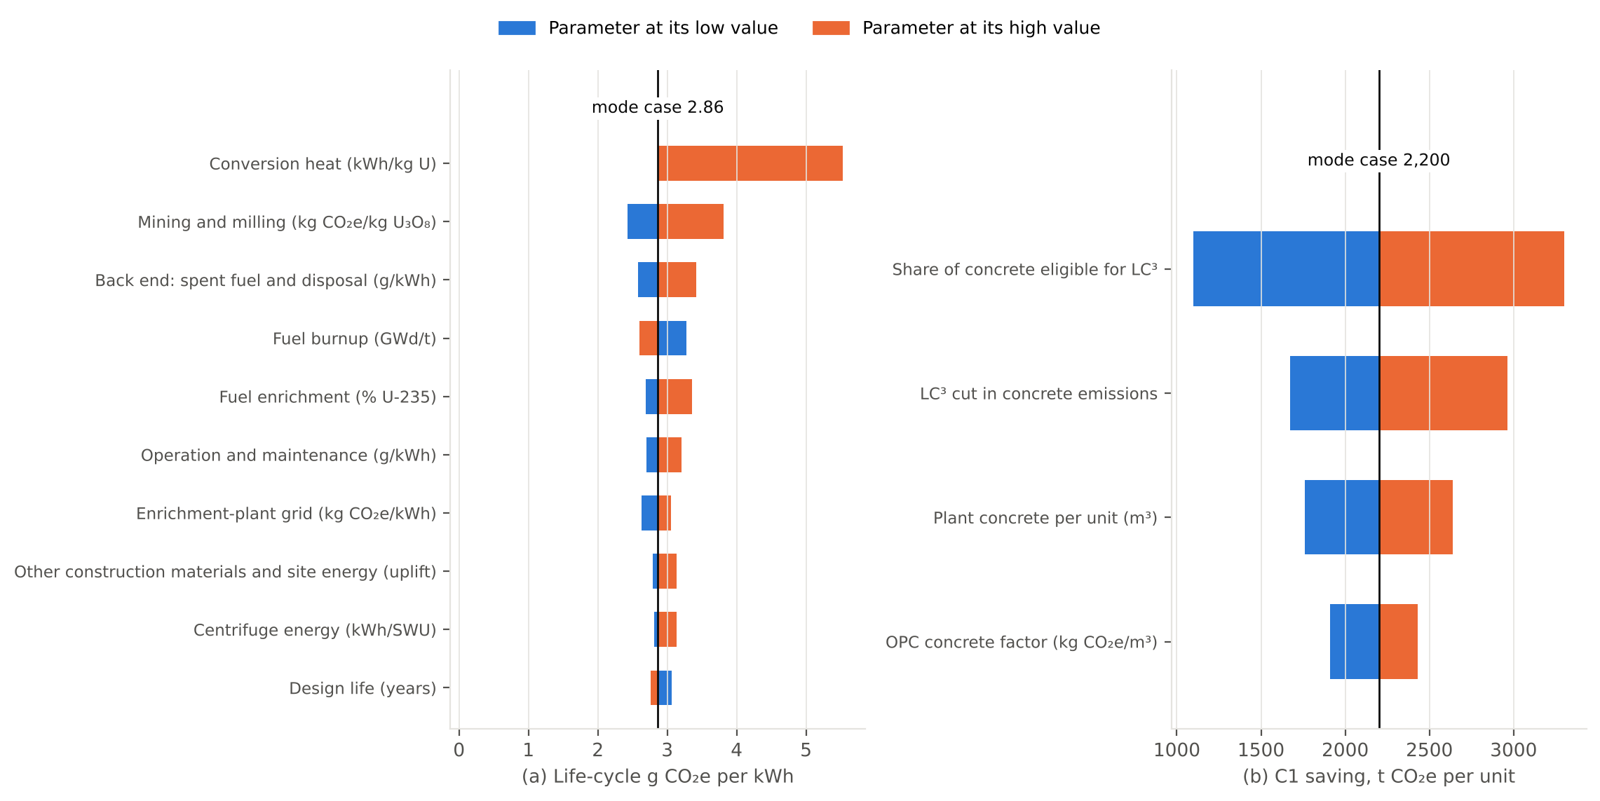
Figure F3. One-at-a-time sensitivity of life-cycle intensity (left, centred on the 2.86 g CO₂e/kWh mode case) and of C1’s saving per unit (right, centred on 2,200 t), top ten inputs each. | Source: this study, Appendix C2.
Monte Carlo (Figure F4): why we report 4.4, not 2.9. Several inputs can mostly only rise: conversion heat is most likely 26 kWh/kg U but could be 665, which alone adds about 1.0 g/kWh to the mean (Appendix C5). We therefore quote the median, and its dependence on conversion heat: fixed at Gibon and Hahn Menacho’s (2023) central 26 kWh/kg U, the median is 3.51 g/kWh (2.80–4.39); log-uniform over 26–665, 4.11 (3.06–6.12). We quote the range of medians, 3.51–4.40. Many ranges are judgement (Appendix C6).
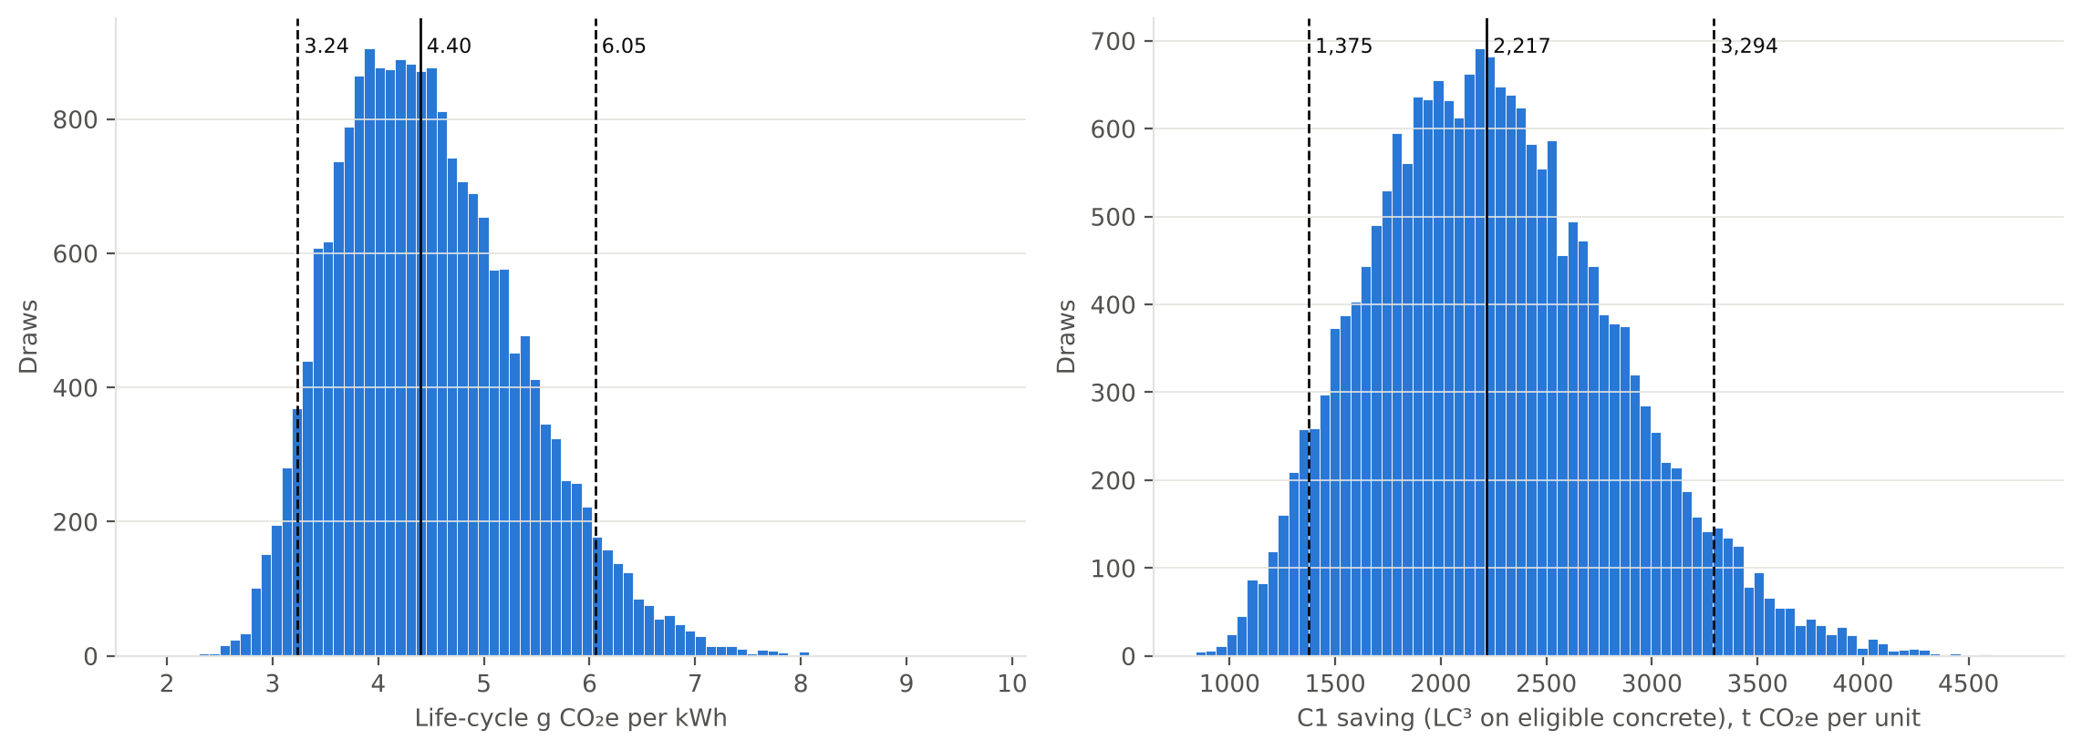
Figure F4. Monte Carlo distributions (20,000 draws) of life-cycle intensity (median 4.40, 5th–95th percentile 3.24–6.05 g CO₂e/kWh) and of C1’s saving per unit at central eligibility. | Source: this study, Appendix C4.

3.2.5 Comparison with published values
Our median (3.5–4.4 across conversion-heat assumptions) is below UNECE’s 5.1–6.4 g/kWh (United Nations Economic Commission for Europe, 2021), though our 90% interval overlaps it, and sits at the low end of the wider literature for reasons we can identify (Figure F5). It overlaps EDF’s French fleet (3.7; EDF R&D, 2024) and is below the global average of 6.1 (Gibon and Hahn Menacho, 2023), an SMR estimate of 9.1 (Carless, Griffin and Fischbeck, 2016) and the harmonised and IPCC AR5 medians of 12 (Warner and Heath, 2012; Schlömer et al., 2014). Gas combined cycle (403–513 g/kWh) and coal (751–1,095) are 90–120 and 170–250 times higher (United Nations Economic Commission for Europe, 2021).
Three reasons explain most of the gap (Appendix C7): Ore grade: our mining is 1.0–1.3 g/kWh, against about 2.8 at global-average grades (Gibon and Hahn Menacho, 2023). Enrichment: centrifuges at 50 kWh per separative work unit, against about 2,500 for older diffusion plants. Cut-offs and long life: a 60-year life biases the result low; at 40 years the mode case rises from 2.86 to 3.07 g/kWh.
The known low bias would raise the total and shrink C1’s share, so it does not weaken Section 3.2.3.
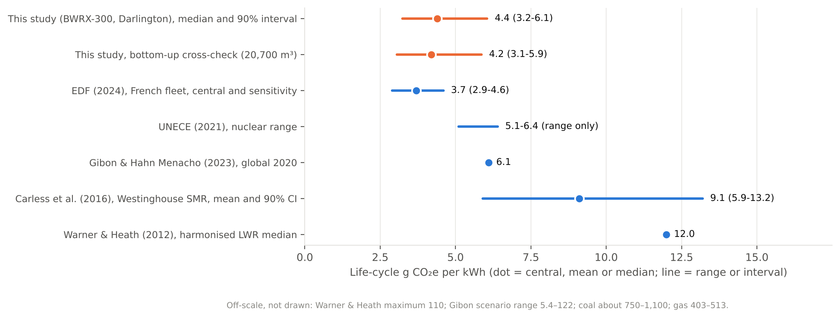
Figure F5. Our result against published nuclear life-cycle values (dot = central or median; line = range or interval). Coal and gas are off the scale. | Source: this study; EDF R&D (2024); United Nations Economic Commission for Europe (2021); Gibon and Hahn Menacho (2023); Carless, Griffin and Fischbeck (2016); Warner and Heath (2012).

3.3 National Strategies and Industrial Policies: Carbon Avoided in Ontario and Australia
For C1, schedule matters far more than concrete. A one-month slip of Units 2–4 costs C$33–110 m in carrying cost alone, 29–175 times the carbon value of C1’s whole saving, and defers about C$88 m of output. C1’s 2,200 t per unit (1,100–3,300; Section 3.2.3) is cancelled by 11.6–18.5 days of delay on Ontario’s average grid factor, or 1.7–1.8 days on its marginal factor. Timing also decides where an SMR helps the climate, and firmed renewables beat both sites on the same money (Appendix B4–B6).

3.3.1 The value of schedule
A late unit gives up each day’s displacement (Table T6). To 2050 (“gross”) the loss is permanent; over the whole life (“net”) it returns at end of life, on a cleaner grid.
Table T6. Days of delay that cancel C1’s saving of 2,200 t per unit (1,100–3,300), Darlington Units 2–4, start 2035. Source: this study, Appendix B5; inputs (BWRX-300 Ostrołęka sp. z o.o., 2023; Pillai et al., 2019); grid factors (The Atmospheric Fund, 2025).
Ontario grid case | CO₂e lost per day, one unit (t, gross / net) | Days that cancel one unit’s saving (gross / net) | Days to one unit that cancel all Units 2–4’s saving (gross / net)
Average, falling to 15 g/kWh by 2040 | 189 / 119 | 11.6 (5.8–17.5) / 18.5 (9.2–27.7) | 35 / 55
Marginal (gas), leaving the margin by 2050 | 1,296 / 1,226 | 1.7 (0.8–2.5) / 1.8 (0.9–2.7) | 5.1 / 5.4
In money the gap is wider. At Canada’s industrial carbon price of C$95/t in 2026 and C$115/t in 2030 (Environment and Climate Change Canada, 2026), the 6,600 t saved across Units 2–4 is worth C$0.63–0.76 m. A one-month slip of the three units costs C$33–110 m in carrying cost (3–10% a year on C$13.2 bn, an upper bound) and defers about C$88 m of output at OPG’s C$149/MWh (Ontario Power Generation, 2026b). Schedule neutrality is therefore the binding condition on C1, and the mix must be qualified on Unit 1 mock-ups before the 2028 Units 2–4 decision (Section 3.6.2).

3.3.2 What one BWRX-300 displaces: Darlington vs Liddell
At today’s grid factors, a unit at Liddell would avoid about nine times more CO₂e than one at Darlington. Timing closes most of that gap. One unit avoids 1.50 Mt a year on the NSW average of 640 g/kWh (DCCEEW, 2025). On Ontario’s 2024 average of 73.8 g/kWh it avoids 0.165 Mt (9.1× less), and on its marginal factor of 343 g/kWh 0.80 Mt (1.9× less) (The Atmospheric Fund, 2025).
The plants would not run in the same years. Darlington Unit 1 is planned for 2030 (Ontario Power Generation, 2025a); Australia’s earliest date for nuclear is 2040 (Graham, Hayward and Foster, 2024), against the Coalition’s 2035 as reported (ABC News, 2024). If coal leaves the NEM by 2038 (Australian Energy Market Operator, 2024), a 2040 unit displaces only a residual 30 g/kWh (assumed).
To 2050 (Figure F6), Darlington Unit 1 avoids 1.0–6.8 Mt and Liddell 0.67–3.9 Mt; Liddell wins clearly only if the NEM stays at 640 g/kWh (16.5 Mt). Grid trajectory, start year and post-coal floor move these results tenfold; capacity factor and our life-cycle interval move them by a few per cent (Appendix B4). An SMR’s climate value depends on when it runs and what it displaces, not on today’s coal share.
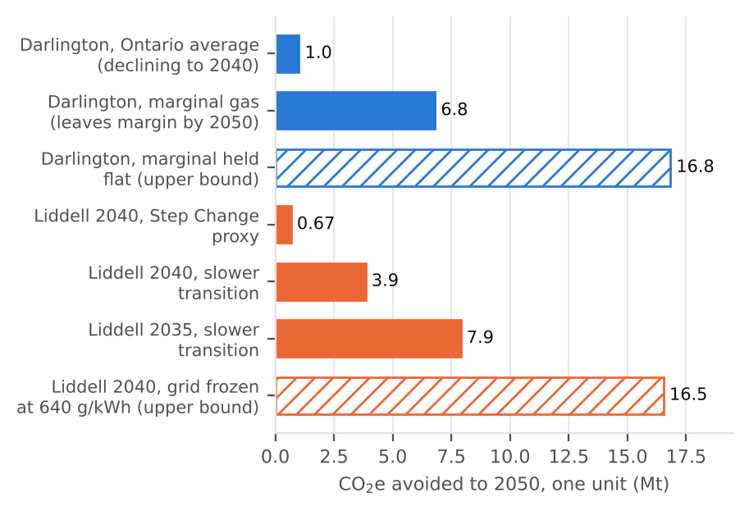
Figure F6. CO₂e avoided to 2050 by one BWRX-300: Darlington Unit 1 (from 2030) against Liddell (from 2035 or 2040), by grid case; hatched bars are upper bounds. | Source: this study, Appendix B4 (Table B17)

3.3.3 The same money on firmed renewables
At GenCost’s 2030 costs, the money for one SMR unit would buy about 2.9 times as much energy from firmed renewables, which would avoid about 11 times more CO₂e to 2050 at Liddell.
GenCost 2023-24 gives A$230–382/MWh for an SMR in 2030, against A$89–125 for solar and wind with integration costs (Graham, Hayward and Foster, 2024, as reported). With renewables from 2028 (assumed) and the SMR from 2040, renewables avoid 10.9× more CO₂e to 2050. They still avoid 5.7× more in the worst case we tested for them (SMR A$230, renewables A$153), and 4.9× with the SMR at A$198 (Appendix B6, Table B28). If A$387–641 is the 2030 range instead, the ratios become 5.0× and 19.1×.
Renewables win because they are cheaper per MWh and start about a decade earlier; integration costs rise beyond the shares GenCost models. On carbon per dollar, an SMR at Liddell loses. Its case rests on firm supply, system security and a hedge against renewables falling behind, which Section 3.7 weighs.
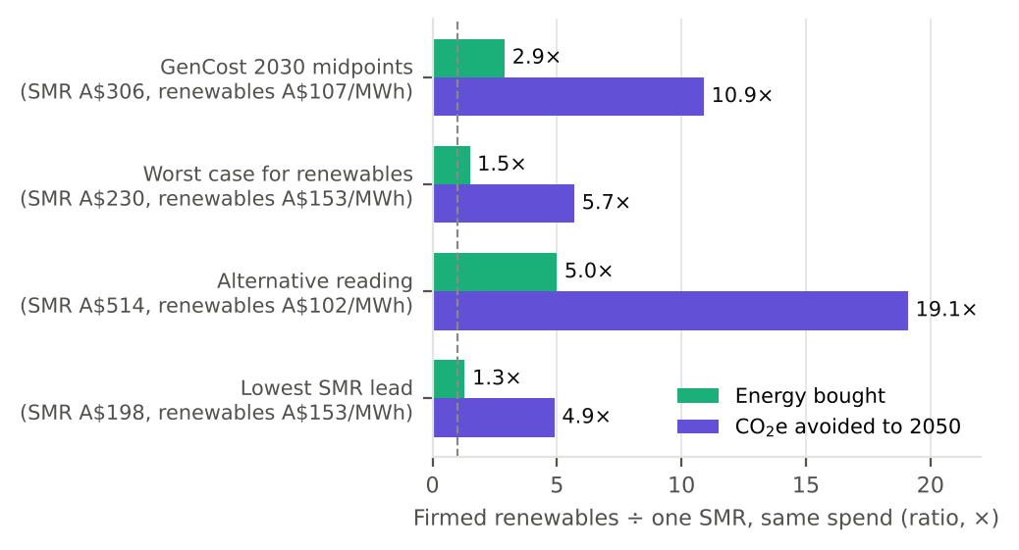
Figure F7. Same money at Liddell: firmed renewables ÷ one SMR unit, as energy bought and CO₂e avoided to 2050, under four cost cases; the dashed line is parity. | Source: this study, Appendix B6 (Table B28)

3.4 Stakeholder Analysis

3.4.1 Stakeholders and money flows
At Darlington none of the seven high-power actors opposes the project; at Liddell three of the four do (the Commonwealth, NSW and AGL), and the only strong supporter, the federal Coalition, is in opposition. Our power-weighted stance scores (−2 to +2; our judgement, not survey data; Figure F8; Appendix B8.2) are +1.07 and −1.03.
Table T7 sets each actor’s influence beside its money. OPG carries about 78% of Darlington on its balance sheet (our calculation), repaid through rates the Ontario Energy Board approves, while public and First Nations finance lowers the cost of capital. That model needs a publicly owned utility with a regulated rate base; Liddell’s private owner would need Commonwealth ownership or underwriting (Section 3.5.1), with taxpayers carrying the cost risk, as reported by ABC News (2024).
For C1, the decisive actors are OPG as buyer, GE Vernova Hitachi as owner of the infill specification, and the two equity funds at the Units 2–4 tranche (Section 3.5.1). None is opposed, but none yet has a reason to act; the tranche condition supplies one (Section 3.6.2).
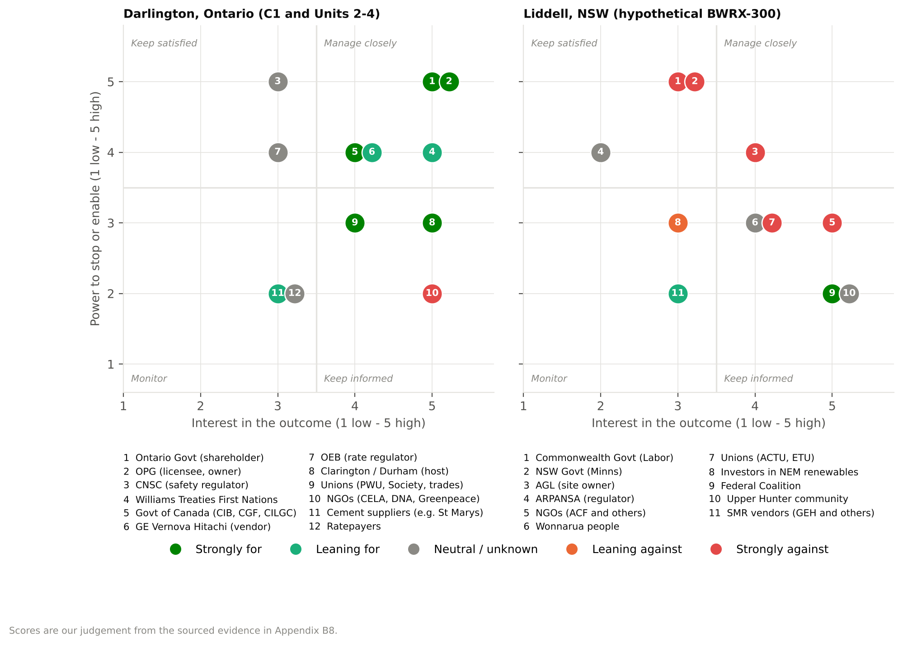
Figure F8. Stakeholder power/interest maps for Darlington Units 2–4 with C1 (left) and a hypothetical Liddell BWRX-300 (right). Colour shows stance; positions are our judgement from Sections 3.4–3.6. Source: this study, Appendix B8.2.
Table T7. Stakeholders at the C$20.9 bn Darlington New Nuclear Project: influence, interest in C1, and money. Source: influence ratings and interests are our qualitative judgement, not survey data; money as cited in each row; shares calculated in Appendix B8.4.
Stakeholder | Influence | Primary interest in C1 | Money (share of budget)
OPG and its design authority | Very high | Safety, delivery; oversee qualification and a fallback mix | Pays C$16.2 bn (78%), repaid by ratepayers through Ontario Energy Board-approved rates (Ontario Power Generation, 2025b)
CNSC | Very high | Independent safety case | None
Williams Treaties First Nations | High | Long-term participation; rights-respecting engagement | Loan converting to equity, C$0.70 bn (3.3%); guarantors carry default risk (Williams Treaties First Nations et al., 2026)
Public financiers and investors | High | Investment risk, delivery milestones | Canada Infrastructure Bank loan, C$0.97 bn (4.6%) (Canada Infrastructure Bank, 2022); equity, C$3.0 bn (14.4%) (Canada Growth Fund and Building Ontario Fund, 2025)
Contractors and suppliers | High | Constructability, price, traceability | Earn the construction revenue, with GE Vernova Hitachi
Clarington residents and customers | Medium–high | Air and water impacts, cost | Repay OPG’s share through rates

3.4.2 Social licence
The same reactor has a social licence at Darlington and none at Liddell. Safety data do not explain the difference; consent, benefit and trust do (Table T8).
In 2024, 61% of Australians supported using nuclear power to generate electricity (Neelam, 2024), yet 59% wanted to keep the legal ban, up from 51% a year earlier (Griffith University Climate Action Beacon and Monash Climate Change Communication Research Hub, 2025). One poll asks about a technology and the other about the law, so support depends on framing. The health benefit, like the carbon benefit (Section 3.3), depends on what the reactor displaces.
Consent: equity in Canada, failed top-down siting in Australia. At Darlington the CNSC found the duty to consult met (CNSC, 2025). In June 2026 the seven Williams Treaties First Nations announced a C$700 m investment, a loan converting to equity once all four units are complete, backed by federal and Ontario loan guarantees of about C$715 m (Williams Treaties First Nations et al., 2026; Government of Canada, 2026). Two of the seven told the CNSC in 2023–24 that their concerns had not been addressed (Mississaugas of Scugog Island First Nation, 2023; Curve Lake First Nation, 2024), so ownership is not universal consent. Australia’s precedent is a waste site chosen top-down and set aside by the Federal Court for apprehended bias (Barngarla Determination Aboriginal Corporation RNTBC v Minister for Resources [2023] FCA 809); Canada’s waste agency used volunteer siting and a priced hosting agreement (Nuclear Waste Management Organization [NWMO], 2024a). Scored on legitimacy, legal risk, speed, public cost and fairness, consent-based routes beat top-down siting by 3–6 points under every weighting, and not building scores highest (Appendix B8.3).
C1 changes no land use, emissions or waste at the site, so it raises no new consent issue there; its social value is indirect, as a lower-carbon build that OPG can report to its First Nations and public equity partners (our inference). A socially sustainable pilot would disclose clay source locations and routes early, open supply to Indigenous and local firms where suitable, and report environmental data plainly. Waste stewardship is unchanged: the NWMO repository near Ignace entered regulatory assessment in January 2026 and is not operating (Nuclear Waste Management Organization, 2026). For Liddell, low-regret steps can precede any repeal: a producer-funded waste body and a two-key test in which both the host community and the Traditional Owners must agree, then a priced hosting agreement, First Nations equity with a loan guarantee and a skills plan coordinated with AUKUS (Section 3.6.2).
Table T8. Social licence at Darlington and at Liddell. Source: as cited in each cell; full source list in Appendix B8.
Factor | Darlington, Ontario | Liddell, NSW (hypothetical) | Effect on translation to practice
Deaths per TWh; deaths avoided per unit-year | Nuclear 0.03 vs gas 2.82 (Ritchie, 2020): about 6.6 avoided if gas is displaced | Coal 24.62: about 58, an upper bound (Markandya and Wilkinson, 2007) | Nuclear is about 820 times safer than coal, yet “dread” keeps acceptance low (Slovic, 1987)
Traditional Owners and consent | Duty to consult met; C$700 m loan converting to equity | Wonnarua people: no public position located; no process. Kimba ballot 61.6% yes, Barngarla excluded | Canada has a funded way to say yes; Australia has none
Waste route | Volunteer siting from 2010: 22 communities to 1; Ignace vote 77%; C$170 m over 81 years to the host; C$26 bn paid by producers (NWMO, 2024c; n.d.) | No disposal route, even for research-reactor waste | Waste is a hard gate for Liddell
Workforce | About 1,600 construction and 200 operating jobs per SMR (Conference Board of Canada, 2021) | No civil nuclear workforce; AUKUS needs about 20,000 jobs over 30 years (Joint Standing Committee on Treaties, 2024) | A civil SMR would compete with AUKUS for trades

3.5 Market Analysis and Economic Feasibility

3.5.1 Economics, finance and market barriers
An SMR’s cost is mostly capital, so whoever finances it sets its price and decides who can build one. C1 is the opposite: it costs almost nothing, but no one is paid for the carbon it saves.
Darlington’s C$20.9 bn budget for four 300 MWe units (Ontario Power Generation, 2025a) gives a levelised cost of electricity (LCOE: the constant price that repays every cost over the plant’s life) of C$198/MWh at a 7% real discount rate, and C$112–280 from 3% to 10% (Table T10). Capital is 65–86% of it, so finance terms matter as much as engineering. OPG’s C$149/MWh implies 4.9%, a regulated Crown utility’s cost of capital. Our A$221 at 7% sits just below GenCost’s 2030 SMR range (Graham, Hayward and Foster, 2024), though GenCost’s current edition bases its SMR capital cost on Darlington (Graham and Hayward, 2026), so the agreement is not independent. A NuScale-size overrun would give C$317/MWh.
NuScale’s Idaho project shows what happens when buyers carry overrun risk: its price rose about 35% in real terms even after tax credits, the Utah utilities did not subscribe, and it was cancelled in 2023 (Table T10). Darlington avoids this with a single Crown owner and a regulated rate base; public and First Nations finance covers about 22% of the budget (Section 3.4.1). The Canada Growth Fund (up to C$2 bn) and Building Ontario Fund (up to C$1 bn) supply equity, and the C$715 m of First Nations loan guarantees is credit support, not extra spending (Government of Canada, 2026). The second equity tranche is released for Units 2–4 “once project milestones are met” (Canada Growth Fund and Building Ontario Fund, 2025), which is C1’s main financial lever.
Entry needs large up-front capital, years of development, component qualification and regulatory approval; a small module is not proportionally cheap because site works, security and licensing are largely fixed (International Atomic Energy Agency, 2023). About C$17,400/kW is at risk for years before any revenue. First plants are financed by states and rate bases: the US Department of Energy’s US$800 m went to two designs, one the BWRX-300 (US Department of Energy, 2025), out of about 70 worldwide (International Atomic Energy Agency, 2024), and China’s State Council approves batches for state-owned builders, as reported (Caixin Global, 2026). Australia has neither route. Liddell belongs to AGL, a private company, so an SMR there would need Commonwealth ownership or underwriting, with taxpayers carrying the cost risk (our inference).
LC³ saves 6,600 t CO₂e across Units 2–4 (2,200 t a unit; Section 3.2.3), worth C$0.63–0.76 m at the federal carbon price of C$95/t in 2026 and C$115/t in 2030 (Environment and Climate Change Canada, 2026; BWRX-300 Ostrołęka sp. z o.o., 2023; Pillai et al., 2019). That justifies an LC³ premium of up to C$10.4–12.7/m³, or 4.6–5.5% of commodity concrete at C$229/m³. The target concrete costs about C$13.7 m, 0.10% of Units 2–4 capital. Table T9 tests the break-even from the cost side: a premium on a unit’s 20,000 m³ of eligible concrete (40% of 50,000 m³) is sensitivity, not a quote, since no supplier price has been obtained. Qualification adds to the abatement cost: a C$1 m programme (assumed) adds about C$152/t, and one day of delay costs C$1.8–2.9 m, more than C1’s whole carbon value. Responses are compared in Section 3.6.2 (Table T13).
Table T9. Material-only cost of an LC³ premium on 20,000 m³ of eligible concrete per unit, against 2,200 t CO₂e saved. Source: this study; premiums assumed. Carbon price from Environment and Climate Change Canada (2026).
Premium | Extra cost per unit | Per t CO₂e saved | Against C$95–115/t
C$10/m³ | C$0.2 m | C$91 | Below the price
C$25/m³ | C$0.5 m | C$227 | Above the price
C$50/m³ | C$1.0 m | C$455 | Above the price
Table T10. Cost evidence for an SMR: our Darlington estimate against published values. Source: this study, Appendix B6.3; Ontario Power Generation (2025a; 2026b); Graham, Hayward and Foster (2024); Rao, Kaffine and Hodge (2026); Steigerwald et al. (2023).
Measure | Value | What it shows
Our Darlington LCOE, real, 60-year life | C$112 / 151 / 198 / 280 per MWh at 3 / 5 / 7 / 10% | Finance terms move it 2.5-fold
GenCost 2023-24, 2030: SMR / large nuclear / firmed solar and wind | A$230–382 / 141–233 / 89–125 per MWh | Our A$221 sits just below the SMR range
Capital cost: vendor BWRX-300 vs Darlington | US$2,250/kW vs about US$12,600/kW | Vendor figures are a fifth of budget
NuScale Carbon Free Power Project, Idaho | Price US$58 to 89/MWh; cost US$5.3 bn to 9.24 bn; cancelled November 2023 (NuScale Power Corporation and Utah Associated Municipal Power Systems, 2023; Schlissel, 2023) | Buyers leave when they carry overruns

3.5.2 Supply concentration and geopolitics
Every front-end fuel stage we measured is concentrated: each Herfindahl–Hirschman index (HHI; Section 2) exceeds 1,800, “highly concentrated” on the 2023 US merger guidelines (US Department of Justice and Federal Trade Commission, 2023), though on the 2010 scale only enrichment is (Table T11). For Darlington this is a price risk; for an Australian SMR it is a sovereign risk.
Russia holds 41.0–42.8% of enrichment capacity (calculated from World Nuclear Association, 2025; World Nuclear University, 2025). Removing Russia, as US buyers must once import-ban waivers end in 2028 (United States Congress, 2024), raises every HHI; without Russia and China, enrichment is a Urenco–Orano duopoly (HHI 5,621). Mining is concentrated by country but not by company (HHI about 850–1,400), so its risk is geopolitical (Appendix B2).
OPG’s announced Unit 1 fuel suppliers (Cameco, Urenco USA, Orano, GNF-A) include no Russian firm (Ontario Power Generation, 2023, as reported by Power Engineering, 2023). Four units need about 196 t of natural uranium and 138 thousand separative work units (SWU) a year, about 3.2% of Urenco USA’s output (assumed typical BWR fuel values; Appendix B2.6). Australia holds 28% of identified recoverable uranium resources (OECD Nuclear Energy Agency and International Atomic Energy Agency, 2025; the 2026 edition gives 27–29%) but has no conversion or enrichment (World Nuclear Association, 2026), so an Australian SMR would import enrichment and fabrication by law (EPBC s 140A; ARPANS s 10) and conversion (Parliamentary Library, 2024).
C1 does not reduce fuel risk, and fuel independence needs conversion, enrichment, fabrication, forged components and skilled labour, not uranium deposits alone. Contracts with allied enrichers, as OPG uses, cut a buyer’s exposure but not concentration (Section 3.6.2). C1 adds a small supply risk of its own: LC³ needs a suitable calcined-clay source and blending capacity (Scrivener et al., 2018), and a single qualified supplier would be a risk. One Western option is laser enrichment from Australia’s Silex Systems, commercialised in the US by Global Laser Enrichment (51% Silex, 49% Cameco, OPG’s uranium supplier) (Silex Systems Limited, 2025; 2026, as reported by World Nuclear News, 2026); EPBC s 140A would bar such a plant in Australia (Section 3.8).
Table T11. Herfindahl–Hirschman index (HHI) of the uranium front end, by stage, with and without Russia and China. Source: this study, Appendix B2, from World Nuclear Association (2024; 2025; 2026).
Stage (measure, base year) | HHI | Class (2023 / 2010) | Russia’s share | HHI without Russia | HHI without Russia and China | Australia’s share | Canada’s share
Mining (output by country, 2024) | 2,341 | High / Moderate | 4.5% | 2,546 | 2,686 | 7.6% | 23.8%
Conversion (capacity by company) | 2,111 | High / Moderate | 20.2% | 2,674 | 3,615 | 0% | 20.2%
Enrichment (capacity by company, 2025) | 3,009 | High / High | 42.8% | 3,599 | 5,621 | 0% | 0%

3.6 Government Regulations Review

3.6.1 Law, regulation and licensing
Law is where Darlington and Liddell differ most. At Darlington, C1 starts with LC³ in non-safety concrete and extends to the steel-composite infill only if qualified before the Units 2–4 go-ahead expected in 2028 (American Nuclear Society, 2026, as reported). At Liddell, three laws and the site owner block an SMR (Table T12).
Federal repeal fails in the Senate while Labor and the Greens oppose, so the Coalition’s pledge to “repeal all legislative prohibitions” (Liberal Party of Australia, 2026) cannot pass unless one changes position. Repeal alone would not suffice: ARPANSA licenses only Commonwealth-controlled bodies (ARPANS Act s 13), so a private SMR at Liddell would remain an offence under NSW s 8. Only a Commonwealth-owned operator might fit the s 8(3) exemption that covers ANSTO (our inference).
The construction licence (April 2025) covers one unit, and OPG applied in March 2026 to operate Unit 1 (Canadian Nuclear Safety Commission [CNSC], 2026a; 2026b). Units 2–4 need a further authorisation, with C1 reviewed inside it. Concrete in a non-safety auxiliary structure meets ordinary construction requirements, but infill in a safety-significant structure may alter the licensed design basis and needs a fuller demonstration; REGDOC-2.5.2 classifies structures by risk (CNSC, 2023a). The cement standard already allows calcined-clay blends with up to 15% limestone (CSA Group, 2023; Hooton, 2023). The BWRX-300 containment is steel-plate composite, so the infill is governed by GE-Hitachi’s topical report NEDO-33926, which the CNSC and US NRC jointly reviewed (GE-Hitachi Nuclear Energy, 2024; US Nuclear Regulatory Commission and CNSC, 2025). To our reading the public report does not state a cement-type limit, and we found no nuclear precedent for calcined-clay infill: that is C1’s real licensing risk.
The non-safety pilot needs no nuclear qualification; infill qualification must start in 2027, with slag (S1) as the fallback (Section 3.6.2). At Liddell the barrier precedes any materials choice, and LC³ solves none of them.
Table T12. Legal barriers to an SMR at Liddell and the Darlington equivalent. No row is resolved as at October 2026. Source: legislation as named; Appendix B1; Canadian Nuclear Safety Commission (2021; 2022; 2025).
Barrier | Liddell (NSW) | What removes it; veto holder | Darlington (Ontario)
1. Federal bans | EPBC Act 1999 (Cth) s 140A bars approval; ARPANS Act 1998 (Cth) s 10 bars a licence | Amend both. Senate: about 39 votes needed, at most 37 in favour (Appendix B1.2; Parliament of Australia, 2026) | Licence to construct in about 29 months, against 24–32 expected (CNSC, 2022; 2025)
2. Regulator for a private reactor | None; NSW has no nuclear regulator | Commonwealth-owned plant or a new regulator (Appendix B3) | CNSC established (CNSC, 2026a)
3. NSW ban | Uranium Mining and Nuclear Facilities (Prohibitions) Act 1986 (NSW) s 8 makes building a reactor an offence; s 9 bars approval | NSW repeal (passed the Council 6 May 2026, lapses 28 November 2026; Parliament of New South Wales, 2026) or Constitution s 109 override | Unit 1 approved 8 May 2025 (Government of Ontario, 2025)
4. Site | AGL owns Liddell and has ruled out nuclear (Newcastle Herald, 2024a) | AGL’s consent, or Commonwealth acquisition | OPG holds the site licence (CNSC, 2021)

3.6.2 Implementation pathway
C1 can be built with no added delay on the evidence available if OPG applies a carbon specification to eligible non-safety concrete now (the LC³ pilot), qualifies the steel-composite infill on a Unit 1 mock-up, and ties a milestone to the Units 2–4 equity tranche. The levers in Table T13 are scored on enforceability, speed and low schedule risk (1 to 3 each; our judgement, not sourced scores). L1 and L2 tie at 8. If enforceability counts double, L2 leads with 11; if speed counts double, L1 leads with 11; the recommendation is the same under both. L1 is C1’s pilot step: a 10% floor invites LC³, whose full saving is 1,100–3,300 t CO₂e per unit (Section 3.1.4; Pillai et al., 2019).
Table T13. Levers for putting C1 into practice, compared. Source: our evaluation from Treasury Board of Canada Secretariat (2022); Canada Growth Fund and Building Ontario Fund (2025). Scores are our judgement (Appendix B3.1).
Lever | Who pays | Binding on OPG? When | Schedule risk | Qualification gate; outcome if not met | Score (enforceability / speed / low risk)
L1. OPG specification: environmental product declarations (EPDs) and concrete at least 10% below the regional baseline; non-safety concrete first | OPG, so ratepayers (premium break-even, Section 3.5.1) | Yes; next procurement round (2027) | Low | Each component’s safety function defined, binder traced; if not, revert to the approved mix | 2 / 3 / 3 = 8
L2. Units 2–4 equity-tranche milestone: EPD disclosure and a reduction target, with a schedule-neutral exemption | The funds; no cash cost | Yes, if the funds agree; tranche 2 (around 2028) | Low, if the exemption is written in | EPDs on a comparable product boundary, transport modelled; if not, no quantified saving claim | 3 / 2 / 3 = 8
L3. Ontario shareholder direction to OPG | Ratepayers, after Ontario Energy Board review | Yes; months | Depends on wording | Design-authority acceptance, with CNSC review where relevant; if not, no use in safety-class works | 3 / 2 / 2 = 7
L4. Public funding for qualification on the Unit 1 mock-up (assumed C$1–3 m) | Federal or Ontario research budget | No; 2027 | Removes the main schedule risk | Strength, heat, crack and durability data; if not met, a further trial or rejection | — (enabling step for L1’s infill extension)
The sequence is L1 now, L4 in 2027, then L2 at the 2028 tranche. A CNSC licence condition is not a lever, because the CNSC does not set climate conditions; it only has to accept that the change is safe (our inference). Step 1, in 2027, develops slag and LC³ self-consolidating mixes (about 6 to 9 months). Step 2 is a full-scale mock-up trial off Unit 1’s critical path (about 6 months), funded by L4. Step 3 is the design-change evaluation, submitted with the Units 2–4 licensing package ahead of the approval expected in 2028, as reported (American Nuclear Society, 2026); it takes about 6 to 9 months (assumed). The steps total about 18 to 24 months (assumed), so they fit only if they start in 2027. We have not costed the programme; Section 3.7 tests an assumed C$1 m. If the evidence is not ready, Units 2–4 proceed with the current mix and the infill enters at a later unit. Doing nothing forgoes the saving at near-zero cost and is rejected.
The federal standard is a template, not an obligation. The Standard on Embodied Carbon in Construction (amended March 2025) requires low-carbon concrete and life-cycle assessment in federal procurement (Treasury Board of Canada Secretariat, 2022), but it binds federal departments, and OPG, an Ontario Crown corporation, is outside its scope (our inference). Its allowance of 130% of baseline for specialised mixes could let self-consolidating infill emit 30% more than the baseline, so any OPG or fund clause must benchmark infill against a cement-rich self-consolidating reference mix.

3.7 Triple-bottom-line evaluation and multi-criteria analysis
Adopt C1 only as a schedule-neutral specification; for Australia, the same money on firmed renewables ranks first, ahead of the status quo and of an SMR at Liddell. C1 changes the life cycle by about 0.36%, and no predefined weight set, input test or ±50% weight test puts an SMR first.

3.7.1 Triple bottom line
Table T14. Triple-bottom-line summary: C1 at Darlington Units 2–4 and one BWRX-300 at Liddell. Source: this study, from the sections cited.
 | Darlington, with C1 | Liddell (one unit) | C1 assessment | Traced to
Environment | About 4 g CO₂e/kWh (Section 3.2). C1 saves 2,200 t per unit at 40% eligibility, about 0.36% of the life cycle. Unit 1 avoids 1.0–6.8 Mt to 2050. | Avoids 0.67–3.9 Mt to 2050, from about 2040. Firmed renewables avoid 10.9× more per dollar. | Conditional benefit | Section 3.2.3, Section 3.3
Economy | LCOE C$198/MWh at 7%. C1’s carbon value (C$0.63–0.76 m, Units 2–4) is less than one day of delay (C$1.8–2.9 m). | SMR A$230–382/MWh in 2030 against A$89–125 for firmed renewables. A first unit would need Commonwealth underwriting (our inference, Section 3.5.1). | Conditional feasibility | Section 3.3.3, Section 3.5.1
Society | Stance +1.07; no high-power actor opposed. Williams Treaties First Nations lend C$700 m. C1 adds no consent issue. | Stance −1.03; 59% want the ban kept. No legal route is open. | Acceptability depends on process | Section 3.6.1, Sections 3.4–3.6
Net | Marginal gain; feasible if schedule-neutral (break-even 11.6–18.5 days). | Not feasible before 2040 on current law, cost and consent. | Controlled innovation | Sections 3.2–3.6

3.7.2 Multi-criteria analysis
Method in Section 2; working in Appendix B7 (scores: B8.3, B3).
Table T15. MCDA total scores (0–100) by weight set, and first-place tests. Source: this study, Appendix B7. SMR + C1 is the 2,200 t case. Social, legal and weight inputs are our judgement.
Option | Equal | Climate and cost | Firm and sovereign | Host community
Firmed renewables, same money | 80.1 | 85.9 | 63.7 | 89.3
Status quo | 52.4 | 41.7 | 60.0 | 55.0
One SMR at Liddell | 29.7 | 24.0 | 43.6 | 20.4
SMR + C1 | 29.7 | 24.0 | 43.6 | 20.4
First place changed by a ±50% change in one weight (of 14 tests) | 0 | 0 | 2 | 0
Renewables rank first under every weight set. The SMR wins only on life-cycle CO₂e (about 4 against 30 g/kWh) and supply concentration. It loses on CO₂e avoided per dollar (10.9×), cost (2.9×), time (about 12 years later), social licence and legal feasibility.
Of 56 weight changes of ±50%, two change first place, both under the firm-and-sovereign weights and both to the status quo, not the SMR. An SMR ranks first only if life-cycle CO₂e carries at least 94% of the weight, or in 0.1% of 20,000 random weight sets. Of 68 input tests, renewables stay first in 66.
SMR + C1 and SMR are indistinguishable. At 2,200 t per unit (BWRX-300 Ostrołęka sp. z o.o., 2023; Pillai et al., 2019), C1 moves the weighted score by under 0.005 point. At Liddell, an 18.5-day slip would forgo CO₂e equal to 15 times the saving (Appendix B7.5). The status quo’s second place over the SMR is a scaling artefact: it scores full marks on cost, supply and legal feasibility because it changes nothing.

3.7.3 Verdict and limits
C1 is justified as a controlled innovation within a credible nuclear construction programme, not as an argument that all SMRs should be built. Pilot LC³ in eligible non-safety works first; use steel-composite infill only if qualified on Unit 1 mock-ups, otherwise the slag blend. Qualification must start in 2027 for the 2028 Units 2–4 decision (Section 3.6.2).
An SMR at Liddell would need its cost gap closed, first power well before 2040, and the legal and consent barriers removed (Appendix B3, route C). We would keep SMRs under review against Darlington’s outturn cost.
The social, legal and supply scores and all four weight sets are our judgement; only “renewables first” is robust to the scaling. Costs are GenCost’s (Graham, Hayward and Foster, 2024); the renewables supply score uses solar PV alone (International Energy Agency, 2022).

3.8 Future material properties and processes
C1 and the levers beyond it each depend on a property or process still to be proven (Table T16).
Table T16. What must be proven. Source: as cited in the cells.
Need | Evidence now | To prove
SCC LC³ for DP-SC infill | Calcined clay raises superplasticiser demand (Universität der Bundeswehr München, n.d.); no heat data found; M50 strength 56.7 against 60.0 MPa (Pillai et al., 2019) | Mock-up panels testing flow, heat and shrinkage; qualification under NEDO-33926 before approval expected in 2028 (American Nuclear Society, 2026)
Low-residual EAF nuclear plate | Scrap-EAF steel emits 0.68 against 2.33 t CO₂/t (World Steel Association, 2026), but copper limits scrap use (Canadian Nuclear Safety Commission, 2023b) | Qualify diluted-scrap or direct-reduced-iron plate (our inference)
Laser enrichment | Enrichment is the most concentrated fuel-cycle step (Section 3.5.2); a US laser plant’s application was accepted in August 2025 (Silex Systems Limited, 2025) | NRC licence decision; Australian law (EPBC s140A, ARPANS s10) bars it
Waste forms | Three non-BWRX SMR designs may produce 2–30 times more waste by volume (Krall, Macfarlane and Ewing, 2022; contested); Synroc is pre-commissioning (ANSTO, n.d.) | Synroc commissioning

4 Conclusion
Pilot LC³ in eligible non-safety works first; use it in the infill only if qualified on Unit 1 mock-ups and adding no delay to Darlington Units 2–4. For Australia, law, cost and timing bar an SMR at Liddell before about 2040; firmed renewables rank first.
Our answers to the four research questions are as follows.
- Life cycle (Section 3.2). One BWRX-300 emits about 4 g CO₂e/kWh, mostly from the fuel front end; conversion heat is the largest uncertainty.
- C1 (Sections 3.2–3.3). It saves 2,200 t per unit (1,100–3,300; Section 3.1.4), about 0.36% of the life cycle; a delay of 11.6–18.5 days cancels it (1.7–1.8 days on the marginal grid factor).
- Displacement (Section 3.3). Darlington Unit 1 avoids 1.0–6.8 Mt CO₂e to 2050 and a Liddell unit 0.67–3.9 Mt; firmed renewables avoid 10.9 times more per dollar.
- Barriers and options (Section 3.1.3, Sections 3.4–3.7). Law (three bans), cost (C$149–198/MWh) and time (2040 at the earliest) decide; firmed renewables rank first under all four weight sets (80 against 30 with equal weights).
Schedule: a month’s slip to Units 2–4 costs 29–175 times C1’s carbon value (Section 3.3). Fuel front end: a measured conversion-heat value would narrow the headline most (Section 3.2). Whole-plant steel: up to 3,714 t per unit, if feasible (Section 3.8). Concrete (C1): low-risk, but moves the life cycle by about 0.36%.
A screening LCA, not critically reviewed; MCDA weights are our judgement; legislation excludes the 2025 EPBC reforms.

5 References
ABC News, 2024. Peter Dutton reveals seven sites for proposed nuclear power plants. ABC News, 19 June. [online] Available at: https://www.abc.net.au/news/2024-06-19/dutton-reveals-seven-sites-for-proposed-nuclear-power-plants/103995310 [Accessed 20 October 2026].
American Institute of Steel Construction, 2022. Buy Clean California quick guide. [pdf] Available at: https://www.aisc.org/contentassets/937a380ddd404a2da0c48669d438bf3b/quickguide_buycleancali2022.pdf.
American Nuclear Society, 2026. North American construction is back—smaller and faster—at OPG’s Darlington. Nuclear Newswire, 5 June. [online] Available at: https://www.ans.org/news/2026-06-05/article-8047/north-american-construction-is-back-smaller-and-faster-at-opgs-darlington/ [Accessed 20 October 2026].
ANSTO, n.d. ANSTO Synroc. [online] Lucas Heights: Australian Nuclear Science and Technology Organisation. Available at: https://ansto.gov.au/products-services/ansto-synroc [Accessed 25 October 2026].
The Atmospheric Fund, 2025. Ontario Electricity Emissions Factors and Guidelines: 2025 Edition. [pdf] Toronto: The Atmospheric Fund. Available at: https://taf.ca/custom/uploads/2025/10/2025TAF-EmissionsFactors.pdf.
Australian Energy Market Operator, 2024. 2024 Integrated System Plan for the National Electricity Market. Melbourne: AEMO.
Australian Energy Regulator, 2021. Decision notice: AGL application, 30 April 2021. [pdf] Available at: https://www.aer.gov.au/system/files/Decision%20notice%20-%20AGL%20application%2030%20April%202021.pdf.
BWRX-300 Ostrołęka sp. z o.o., 2023. Small Modular Nuclear Power Plant: Project Information Sheet. [pdf] Table 14, p. 83. Available at: https://am.lrv.lt/media/viesa/saugykla/2024/2/oHCKCUp7Lrs.pdf
Caixin Global, 2026. Beijing clears eight new reactors as China accelerates nuclear buildout. Caixin Global, 1 August.
Canada Growth Fund and Building Ontario Fund, 2025. Canada Growth Fund and Building Ontario Fund announce innovative equity investment in world-leading Ontario Power Generation SMR project. [online] Newswire.ca, 23 October. Available at: https://www.newswire.ca/news-releases/canada-growth-fund-and-building-ontario-fund-announce-innovative-equity-investment-in-world-leading-ontario-power-generation-smr-project-862778443.html [Accessed 20 October 2026].
Canada Infrastructure Bank, 2022. CIB commits $970 million towards Canada’s first Small Modular Reactor (SMR). [online] Toronto: Canada Infrastructure Bank. Available at: https://cib-bic.ca/en/medias/articles/cib-commits-970-million-towards-canadas-first-small-modular-reactor/ [Accessed 20 October 2026].
Canadian Nuclear Safety Commission, 2021. CNSC renews Ontario Power Generation’s site preparation licence for its Darlington New Nuclear Project. [online] News release, 12 October. Available at: https://www.canada.ca/en/nuclear-safety-commission/news/2021/10/cnsc-renews-ontario-power-generations-site-preparation-licence-for-its-darlington-new-nuclear-project.html [Accessed 20 October 2026].
Canadian Nuclear Safety Commission, 2022. REGDOC-3.5.1, Licensing Process for Class I Nuclear Facilities and Uranium Mines and Mills, Version 2.1. [online] Available at: https://www.cnsc-ccsn.gc.ca/eng/acts-and-regulations/regulatory-documents/published/html/regdoc3-5-1-v2-1/ [Accessed 20 October 2026].
Canadian Nuclear Safety Commission, 2023a. REGDOC-2.5.2, Design of Reactor Facilities: Nuclear Power Plants, Version 2.1. [online] Ottawa: Canadian Nuclear Safety Commission. Available at: https://www.cnsc-ccsn.gc.ca/eng/acts-and-regulations/regulatory-documents/published/html/regdoc2-5-2-v2-1/ [Accessed 25 October 2026].
Canadian Nuclear Safety Commission, 2023b. Regulatory consideration of environmental degradation in licensing light water small reactors in Canada. [online] Technical paper. Ottawa: Canadian Nuclear Safety Commission. Available at: https://cnsc-ccsn.gc.ca/eng/resources/research/technical-papers-and-articles/2023/regulatory-consideration-of-environmental-degradation-in-licensing-light-water-small-reactor-in-canada [Accessed 25 October 2026].
Canadian Nuclear Safety Commission, 2024. CMD 24-H3-1B (staff presentation, Darlington New Nuclear Project). [pdf] Ottawa: Canadian Nuclear Safety Commission. Available at: https://api.cnsc-ccsn.gc.ca/dms/digital-medias/CMD-24-H3-1B.pdf/object.
Canadian Nuclear Safety Commission, 2025. Commission authorizes Ontario Power Generation Inc. to construct 1 BWRX-300 reactor at the Darlington New Nuclear Project site. [online] News release, 4 April. Ottawa: Canadian Nuclear Safety Commission. Available at: https://www.canada.ca/en/nuclear-safety-commission/news/2025/04/commission-authorizes-ontario-power-generation-inc-to-construct-1-bwrx-300-reactor-at-the-darlington-new-nuclear-project-site.html [Accessed 20 October 2026].
Canadian Nuclear Safety Commission, 2026a. Darlington New Nuclear Project. [online] Ottawa: Canadian Nuclear Safety Commission. Available at: https://www.cnsc-ccsn.gc.ca/eng/reactors/new-reactor-power-plant-projects/new-reactor-power-plant-facilities/darlington-new-nuclear-project/ [Accessed 20 October 2026].
Canadian Nuclear Safety Commission, 2026b. Regulatory hold points for new reactor facilities. [online] Available at: https://www.cnsc-ccsn.gc.ca/eng/reactors/regulatory-hold-points/new-reactors/ [Accessed 20 October 2026].
Canadian Ready-Mixed Concrete Association, 2022. Industry-wide EPD for ready-mixed concrete, Ontario (EPD 351, valid to 27 July 2027). [pdf] Available at: https://www.rmcao.org/wp-content/uploads/2023/04/CRMCA-EPD-Ontario-20220803.pdf.
Carless, T.S., Griffin, W.M. and Fischbeck, P.S., 2016. The environmental competitiveness of small modular reactors: a life cycle study. Energy, 114, pp.84–99. Available at: https://ideas.repec.org/a/eee/energy/v114y2016icp84-99.html.
Concrete Reinforcing Steel Institute, 2017. Industry-wide EPD for fabricated steel reinforcing bar. [pdf] Available at: https://www.astm.org/v3/assets/blt5eb0a2cb04534832/blt4900ac0ff22764a2/697b1fc25e3544dd57d83a3d/362.EPD_for_CRSI_EPD_FINAL_2017-08-28.pdf.
Conference Board of Canada, 2021. A New Power: The Economic Impacts of Small Modular Reactors. Ottawa: Conference Board of Canada.
CSA Group, 2023. CSA A3000:23, Cementitious materials compendium (includes CSA A3001:23, Cementitious materials for use in concrete). [online] Toronto: CSA Group. Available at: https://www.csagroup.org/store/product/2430659/ [Accessed 20 October 2026].
Curve Lake First Nation, 2024. Written submission, CMD 24-H3.83, DNNP licence to construct, 11 November. Available at: https://api.cnsc-ccsn.gc.ca/dms/digital-medias/CMD24-H3-83.pdf/object [Accessed 21 October 2026].
Department of Climate Change, Energy, the Environment and Water, 2025. Australian National Greenhouse Accounts Factors: 2025. [pdf/xlsx] Canberra: Department of Climate Change, Energy, the Environment and Water.
Dodgson, J.S., Spackman, M., Pearman, A. and Phillips, L.D., 2009. Multi-criteria analysis: a manual. London: Department for Communities and Local Government. Available at: https://www.gov.uk/government/publications/multi-criteria-analysis-manual-for-making-government-policy [Accessed 21 October 2026].
EDF R&D, 2024. Life cycle assessment of nuclear power in France: EDF case study. EPJ Nuclear Sciences & Technologies, 10, art. 5. Available at: https://www.epj-n.org/10.1051/epjn/2024005.
Environment and Climate Change Canada, 2026. Industrial carbon pricing in Canada. Ottawa: Government of Canada. Available at: https://www.canada.ca/en/environment-climate-change/services/climate-change/pricing-pollution-how-it-will-work/putting-price-on-carbon-pollution/industry.html [Accessed 21 October 2026].
Fermi Energia, n.d. New SMR project. [online] Tallinn: Fermi Energia. Available at: https://fermi.ee/new-smr-project/ [Accessed 25 October 2026].
Field, K.G., Remec, I. and Le Pape, Y., 2015. Radiation effects in concrete for nuclear power plants – Part I: Quantification of radiation exposure and radiation effects. Nuclear Engineering and Design, 282, pp.126–143. Available at: https://www.ornl.gov/publication/radiation-effects-concrete-nuclear-power-plants-part-i-quantification-radiation [Accessed 25 October 2026].
GE Hitachi Nuclear Energy, n.d. GE Hitachi BWRX-300 fact sheet. [pdf] Wilmington, NC: GE Hitachi Nuclear Energy. Available at: https://gevernova.com/content/dam/gepower-nuclear/global/en_US/documents/product-fact-sheets/BWRX-300_Fact_Sheet-2020.pdf [Accessed 25 October 2026].
GE-Hitachi Nuclear Energy, 2024. BWRX-300 Steel-Plate Composite Containment Vessel (SCCV) and Reactor Building Structural Design, NEDO-33926, Revision 2 (non-proprietary), 16 August. [pdf] US NRC ADAMS ML24110A134. Available at: https://www.nrc.gov/docs/ML2411/ML24110A134.pdf [Accessed 20 October 2026].
GE Vernova, n.d. BWRX-300 Small Modular Reactor. [online] Available at: https://www.gevernova.com/nuclear/carbon-free-power/bwrx-300-small-modular-reactor.
GE Vernova, 2026. NRC issues first U.S. construction permit for BWRX-300 small modular reactor at TVA Clinch River. [online] Press release. Available at: https://www.gevernova.com/news/press-releases/nrc-issues-first-us-construction-permit-bwrx-300-small-modular-reactor-tva-clinch-river [Accessed 25 October 2026].
GE Vernova Hitachi Nuclear Energy, n.d. BWRX-300 General Description (005N9751). [pdf] Wilmington, NC: GE Vernova. Available at: https://www.gevernova.com/content/dam/gevernova-nuclear/global/en_us/documents/carbon-free-power/005N9751-BWRX-300-General-Description.pdf.
Gibon, T. and Hahn Menacho, Á., 2023. Parametric life cycle assessment of nuclear power for simplified models. Environmental Science & Technology, 57(38), pp.14194–14205. Available at: https://doi.org/10.1021/acs.est.3c03190.
Government of Canada, 2026. Darlington New Nuclear Project. [online] Ottawa: Major Projects Office, updated 8 July 2026. Available at: https://www.canada.ca/en/privy-council/major-projects-office/projects/national/darlington.html [Accessed 25 October 2026].
Government of Ontario, 2025. Ontario Leads the G7 by Building First Small Modular Reactor. [news release] 8 May. Toronto: Government of Ontario.
Graham, P. and Hayward, J., 2026. GenCost 2025-26: Final report. [pdf] Australia: CSIRO. Available at: https://www.csiro.au/-/media/Energy/GenCost-2025-26-Final/GenCost_2025-26_Final_Report_20260715.pdf.
Graham, P., Hayward, J. and Foster, J., 2024. GenCost 2023-24: Final report. [pdf] Australia: CSIRO. Available at: https://www.csiro.au/-/media/Energy/GenCost/GenCost2023-24Final_20240522.pdf.
Griffith University Climate Action Beacon and Monash Climate Change Communication Research Hub, 2025. What Australians really think of nuclear power. [news release] 2 May. Available at: https://news.griffith.edu.au/2025/05/02/what-australians-really-think-of-nuclear-power/ [Accessed 21 October 2026].
Helmholtz-Zentrum Dresden-Rossendorf, n.d. [Activation of the biological shield of Greifswald NPP Unit 2]. Publication Publ-39008. Dresden: Helmholtz-Zentrum Dresden-Rossendorf. Available at: https://hzdr.de/publications/Publ-39008 [Accessed 25 October 2026].
Hooton, R.D., 2023. [Webinar slides on changes to ASTM cement and concrete standards]. ACI Fall 2023 webinar slides. [pdf] Farmington Hills: American Concrete Institute. Available at: https://www.concrete.org/portals/0/files/pdf/webinars/ws_F23_NEU_DouglasHooton.pdf [Accessed 20 October 2026].
International Atomic Energy Agency, 2023. What are small modular reactors (SMRs)? [online] Vienna: International Atomic Energy Agency. Available at: https://www.iaea.org/newscenter/news/what-are-small-modular-reactors-smrs [Accessed 25 October 2026].
International Atomic Energy Agency, 2024. Small Modular Reactors: Advances in SMR Developments 2024. Vienna: International Atomic Energy Agency.
International Energy Agency, 2022. Solar PV Global Supply Chains. Paris: International Energy Agency. Available at: https://www.iea.org/reports/solar-pv-global-supply-chains [Accessed 21 October 2026].
International Organization for Standardization, 2006a. ISO 14040:2006 Environmental management — Life cycle assessment — Principles and framework. Geneva: International Organization for Standardization.
International Organization for Standardization, 2006b. ISO 14044:2006 Environmental management — Life cycle assessment — Requirements and guidelines. Geneva: International Organization for Standardization. Available at: https://www.iso.org/standard/38498.html.
Joint Standing Committee on Treaties, 2024. Report 224: Agreement among Australia, the UK and the US for cooperation related to naval nuclear propulsion, Chapter 6, ‘Employment and education impacts’. Canberra: Parliament of Australia. Available at: https://www.aph.gov.au/Parliamentary_Business/Committees/Joint/Treaties/NuclearPropulsion/Report/Chapter_6_-_Employment_and_education_impacts [Accessed 21 October 2026].
Krall, L.M., Macfarlane, A.M. and Ewing, R.C., 2022. Nuclear waste from small modular reactors. Proceedings of the National Academy of Sciences of the United States of America, 119(23), e2111833119. Available at: https://doi.org/10.1073/pnas.2111833119 [Accessed 25 October 2026].
Liberal Party of Australia, 2026. Our Plan for Cheaper Power. [online] Available at: https://www.liberal.org.au/our-plan/energy [Accessed 20 October 2026].
Markandya, A. and Wilkinson, P., 2007. Electricity generation and health. The Lancet, 370(9591), pp.979–990. Available at: https://doi.org/10.1016/S0140-6736(07)61253-7 [Accessed 20 October 2026].
Mississaugas of Scugog Island First Nation, 2023. Written submissions to the CNSC: CMD 23-H9.18A (Darlington Waste Management Facility, January 2023); CMD 24-H2.26 (November 2023); CMD 24-H3.81 (November 2024). Available at: https://api.cnsc-ccsn.gc.ca/dms/digital-medias/CMD23-H9-18A.pdf/object [Accessed 21 October 2026].
Neelam, R., 2024. Lowy Institute Poll 2024. Sydney: Lowy Institute. Available at: https://poll.lowyinstitute.org/report/2024/ [Accessed 20 October 2026].
Newcastle Herald, 2024a. AGL says Liddell site will not be used for nuclear power. Newcastle Herald. [online] Available at: https://www.newcastleherald.com.au/story/8557276/agl-says-liddell-site-will-not-be-used-for-nuclear-power [Accessed 20 October 2026].
Newcastle Herald, 2024b. Coalition government could seize Liddell for nuclear power plant; Dutton’s nuclear energy plan divides opinion in the Hunter. Newcastle Herald. [online] Available at: https://newcastleherald.com.au/story/8670020/ and https://newcastleherald.com.au/story/8668177/ [Accessed 21 October 2026].
Nuclear Waste Management Organization, 2024a. The Nuclear Waste Management Organization selects site for Canada’s deep geological repository for used nuclear fuel. [news release] 28 November. Toronto: Nuclear Waste Management Organization. Available at: https://www.nwmo.ca/News/The-Nuclear-Waste-Management-Organization-selects-site-for-Canadas-deep-geological-repository [Accessed 21 October 2026].
Nuclear Waste Management Organization, 2024b. Implementing Adaptive Phased Management 2024–28: Selecting a site. Available at: https://implementationplan.nwmo.ca/2024_28/selecting-a-site/ [Accessed 21 October 2026].
Nuclear Waste Management Organization, 2024c. Mayor and Council of the Township of Ignace sign historic potential hosting agreement with the NWMO. [news release] March. Available at: https://www.nwmo.ca/news/mayor-and-council-of-the-township-of-ignace-sign-historic–potential-hosting-agreement-with-the-nwmo [Accessed 21 October 2026].
Nuclear Waste Management Organization, 2026. Regulatory process: deep geological repository for Canada’s used nuclear fuel project. [online] Toronto: Nuclear Waste Management Organization. Available at: https://www.nwmo.ca/en/Regulatory-process [Accessed 25 October 2026].
Nuclear Waste Management Organization, n.d. Project costs. [online] Available at: https://www.nwmo.ca/Who-we-are/Funding/Project-Costs [Accessed 21 October 2026].
NuScale Power Corporation, 2023. Amendment No. 3 to Development Cost Reimbursement Agreement [exhibit to Form 10-Q / 424B3]. Washington, DC: US Securities and Exchange Commission. Available at: https://www.sec.gov/Archives/edgar/data/1822966/000182296623000092/a101dcraamendment3execut.htm [Accessed 20 October 2026].
NuScale Power Corporation and Utah Associated Municipal Power Systems, 2023. UAMPS and NuScale Power agree to terminate the Carbon Free Power Project [joint press release, 8 November 2023]. Exhibit to NuScale Power Corporation Form 8-K. Washington, DC: US Securities and Exchange Commission. Available at: https://www.sec.gov/Archives/edgar/data/1822966/000182296623000256/uampsnuscalejointpressre.htm [Accessed 20 October 2026].
OECD Nuclear Energy Agency and International Atomic Energy Agency, 2025. Uranium 2024: Resources, Production and Demand. [pdf] Paris: OECD Publishing. Available at: https://www.oecd-nea.org/jcms/pl_103179/uranium-2024-resources-production-and-demand [Accessed 20 October 2026].
OECD Nuclear Energy Agency and International Atomic Energy Agency, 2026. Uranium 2026: Resources, Production and Demand. [pdf] Paris: OECD Publishing. Available at: https://www.oecd-nea.org/jcms/pl_121658/uranium-2026-resources-production-and-demand [Accessed 20 October 2026].
Ontario Power Generation, 2023. OPG selects first fuel suppliers for its small modular reactor. [press release] Toronto: Ontario Power Generation.
Ontario Power Generation, 2025a. OPG reports 2025 first quarter financial results. [online] News release, 13 May. Toronto: Ontario Power Generation. Available at: https://www.opg.com/news-resources/newsroom/release/opg-reports-2025-first-quarter-financial-results/ [Accessed 20 October 2026].
Ontario Power Generation, 2025b. EB-2025-0297, Exhibit D2, Tab 4, Schedule 1: Darlington New Nuclear Project overview (updated 21 May 2026). [pdf] Filed with the Ontario Energy Board. Available at: https://files.opg.com/wp-content/uploads/2026/05/D2-04-01-Darlington-New-Nuclear-Project-Overview_Updated_20260521_260522_191835.pdf [Accessed 20 October 2026].
Ontario Power Generation, 2025c. Darlington New Nuclear Project construction update. [online] Available at: https://www.opg.com/projects-services/projects/nuclear/smr/darlington-smr/.
Ontario Power Generation, 2026a. OPG reports 2026 first quarter financial results. [online] Available at: https://www.opg.com/news-resources/newsroom/release/opg-reports-2026-first-quarter-financial-results/ [Accessed 20 October 2026].
Ontario Power Generation, 2026b. Interrogatory response giving the Darlington New Nuclear Project levelised cost, EB-2025-0297. Filed with the Ontario Energy Board.
Ontario Power Generation, 2026c. Laying the foundation for the G7’s first small modular reactor. [online] 30 April. Available at: https://www.opg.com/news-and-media/story/laying-the-foundation-for-the-g7s-first-small-modular-reactor [Accessed 25 October 2026].
Parker, D.J., McNaughton, C.S. and Sparrow, G.A., 2016. Life cycle greenhouse gas emissions from uranium mining and milling in Canada. Environmental Science & Technology, 50(17), pp.9746–9753. Available at: https://pubs.acs.org/doi/10.1021/acs.est.5b06072.
Parliament of Australia, 2026. Senate composition. [online] Available at: https://www.aph.gov.au/Senators_and_Members/Senators/Senate_composition [Accessed 20 October 2026].
Parliament of New South Wales, 2025. Uranium Mining and Nuclear Facilities (Prohibitions) Repeal Bill 2025: bill details. [online] Available at: https://www.parliament.nsw.gov.au/bills/Pages/bill-details.aspx?pk=18833 [Accessed 20 October 2026].
Parliament of New South Wales, 2026. Legislative Assembly Notice Paper. [pdf] Available at: https://files.parliament.nsw.gov.au/fileapi/ParlFiles/GetArtifact/170%20NOM%20(combined).pdf?serverRelativeUrl=%2Fhp%2Fhousepaper%2F31312%2F170+NOM+%28combined%29.pdf [Accessed 20 October 2026].
Parliamentary Library, 2024. Current prohibitions on nuclear activities in Australia: a quick guide. Research Paper Series 2023–24, Quick Guide. [online] Canberra: Parliamentary Library, Parliament of Australia, 30 May. Available at: https://www.aph.gov.au/About_Parliament/Parliamentary_departments/Parliamentary_Library/Research/Quick_Guides/2023-24/NuclearActivitiesProhibitions [Accessed 21 October 2026].
Peterson, P.F., Zhao, H. and Petroski, R., 2005. Metal and concrete inputs for several nuclear power plants (UCBTH-05-001). [pdf] Berkeley: University of California, Berkeley. Available at: https://fhr.nuc.berkeley.edu/wp-content/uploads/2014/10/05-001-A_Material_input.pdf.
Pillai, R.G. et al., 2019. Service life and life cycle assessment of reinforced concrete systems with limestone calcined clay cement (LC³). Cement and Concrete Research, 118, pp.111–119. Available at: https://doi.org/10.1016/j.cemconres.2018.11.019.
Power Engineering, 2023. OPG selects first fuel suppliers for its small modular reactors. Power Engineering. [online] Available at: https://www.power-eng.com/nuclear/smrs/opg-selects-first-fuel-suppliers-for-its-small-modular-reactors/.
Rao, P., Kaffine, D.T. and Hodge, B.-M., 2026. The consequences of high SMR operating costs in electricity markets. arXiv preprint 2609.08929. Available at: https://arxiv.org/pdf/2609.08929.
Ritchie, H., 2020. What are the safest and cleanest sources of energy? [online] Our World in Data. Available at: https://ourworldindata.org/safest-sources-of-energy [Accessed 20 October 2026].
Schlissel, D., 2023. Eye-popping new cost estimates released for NuScale small modular reactor. Institute for Energy Economics and Financial Analysis. Available at: https://ieefa.org/resources/eye-popping-new-cost-estimates-released-nuscale-small-modular-reactor.
Schlömer, S. et al., 2014. Annex III: Technology-specific cost and performance parameters. In: Climate Change 2014: Mitigation of Climate Change. Contribution of Working Group III to the Fifth Assessment Report of the Intergovernmental Panel on Climate Change. Cambridge: Cambridge University Press.
Scrivener, K., Martirena, F., Bishnoi, S. and Maity, S., 2018. Calcined clay limestone cements (LC3). Cement and Concrete Research, 114, pp.49–56. Available at: https://doi.org/10.1016/j.cemconres.2017.08.017.
Silex Systems Limited, 2025. [ASX announcement on the NRC’s acceptance of GLE’s Paducah licence application], 6 August. Sydney: ASX. Available at: https://announcements.asx.com.au/asxpdf/20250806/pdf/06mkwks19y2zck.pdf.
Silex Systems Limited, 2026. [ASX announcement on Cameco’s offtake agreement for the Paducah Laser Enrichment Facility], 16 September. Sydney: ASX.
Slag Cement Association, n.d. Industry-average EPD for slag cement (USA and Canada). [pdf] Available at: https://www.lafarge.ca/sites/canada/files/images/sca_epd_for_slag_cement.pdf.
Slovic, P., 1987. Perception of risk. Science, 236(4799), pp.280–285.
Steigerwald, B., Weibezahn, J., Slowik, M. and von Hirschhausen, C., 2023. Uncertainties in estimating production costs of future nuclear technologies: a model-based analysis of small modular reactors. Energy, 281, 128204.
Sun, Y. and Kurosaki, K., 2025. Technical overview of recent developments in small modular reactors in the United States. arXiv:2504.02599 [physics.soc-ph]. Available at: https://arxiv.org/abs/2504.02599.
Systematic evaluation of concrete placement reliability in heavily reinforced nuclear structures, 2026. International Journal of Concrete Structures and Materials. Available at: https://link.springer.com/article/10.1186/s40069-026-00964-8 [Accessed 25 October 2026].
Thierfeldt, S., 2019. [Clearance and recycling of materials from decommissioning]. Presentation slides, SOGIN workshop, Rome. [pdf] Available at: https://www.sogin.it/SiteAssets/uploads/2019/media/09_THIERFELDT_Clearance_Recycling_Materials_Decommissioning.pdf [Accessed 25 October 2026].
Treasury Board of Canada Secretariat, 2022. Standard on Embodied Carbon in Construction (amended 20 March 2025). [online] Ottawa: Treasury Board of Canada Secretariat. Available at: https://www.tbs-sct.canada.ca/pol/doc-eng.aspx?id=32814 [Accessed 20 October 2026].
United Nations Economic Commission for Europe, 2021. Carbon Neutrality in the UNECE Region: Integrated Life-cycle Assessment of Electricity Sources. ECE/ENERGY/141. Geneva: United Nations. Available at: https://unece.org/sites/default/files/2021-10/LCA-2.pdf [Accessed 20 October 2026].
United States Congress, 2024. Prohibiting Russian Uranium Imports Act, Public Law 118-62, 13 May 2024. [pdf] Washington, DC: US Government Publishing Office. Available at: https://www.govinfo.gov/content/pkg/PLAW-118publ62/pdf/PLAW-118publ62.pdf [Accessed 20 October 2026].
Universität der Bundeswehr München, n.d. [Self-consolidating mortar with calcined clay]. [pdf] Munich: Universität der Bundeswehr München. Available at: https://athene-forschung.rz.unibw-muenchen.de/doc/141635/141635.pdf [Accessed 25 October 2026].
US Department of Energy, 2015. Technology Readiness Assessment Guide, DOE G 413.3-4A (Admin. Chg 1). [online] Washington, DC: US Department of Energy. Available at: https://www.directives.doe.gov/directives/0413.3-EGuide-04a [Accessed 25 October 2026].
US Department of Energy, 2025. Energy Department Selects TVA and Holtec to Advance Deployment of U.S. Small Modular Reactors. Washington, DC: US Department of Energy. Available at: https://www.energy.gov/articles/energy-department-selects-tva-and-holtec-advance-deployment-us-small-modular-reactors.
US Department of Justice and Federal Trade Commission, 2010. Horizontal Merger Guidelines. [online] Washington, DC: US Department of Justice and Federal Trade Commission, 19 August. Available at: https://www.justice.gov/atr/horizontal-merger-guidelines-08192010 [Accessed 20 October 2026].
US Department of Justice and Federal Trade Commission, 2023. Merger Guidelines. [pdf] Washington, DC: US Department of Justice and Federal Trade Commission, 18 December. Available at: https://www.justice.gov/d9/2023-12/2023%20Merger%20Guidelines.pdf [Accessed 20 October 2026].
US EPA, 2024. Power Profiler: terms, calculations and data sources. [pdf] Available at: https://www.epa.gov/system/files/documents/2024-04/power-profiler-terms-calculations-and-data-sources.pdf.
US Nuclear Regulatory Commission, 2025. NuScale US460. [online] Rockville, MD: US Nuclear Regulatory Commission. Available at: https://www.nrc.gov/reactors/new-reactors/advanced/who-were-working-with/applicant-projects/nuscale-us460.html [Accessed 25 October 2026].
US Nuclear Regulatory Commission and Canadian Nuclear Safety Commission, 2025. CNSC–NRC Joint Report on GEH BWRX-300 Steel-Plate Composite Containment Vessel and Reactor Building Structural Design Topical Report. ADAMS ML25325A075. [pdf] Available at: https://www.nrc.gov/docs/ML2532/ML25325A075.pdf [Accessed 20 October 2026].
Warner, E.S. and Heath, G.A., 2012. Life cycle greenhouse gas emissions of nuclear electricity generation: systematic review and harmonization. Journal of Industrial Ecology, 16(S1), pp.S73–S92. Available at: https://doi.org/10.1111/j.1530-9290.2012.00472.x.
Williams Treaties First Nations, Ontario Power Generation, Government of Ontario and Government of Canada, 2026. Williams Treaties First Nations announce historic $700 million investment in Darlington New Nuclear Project. [press release] 23 June. Available at: https://www.bnnbloomberg.ca/press-releases/2026/06/23/williams-treaties-first-nations-announce-historic-700-million-investment-in-darlington-new-nuclear-project/ [Accessed 21 October 2026].
World Nuclear Association, 2024. Conversion and Deconversion. [online] London: World Nuclear Association. Available at: https://world-nuclear.org/information-library/nuclear-fuel-cycle/conversion-enrichment-and-fabrication/conversion-and-deconversion [Accessed 20 October 2026].
World Nuclear Association, 2025. Uranium Enrichment. [online] London: World Nuclear Association. Available at: https://world-nuclear.org/information-library/nuclear-fuel-cycle/conversion-enrichment-and-fabrication/uranium-enrichment [Accessed 20 October 2026].
World Nuclear Association, 2026. World Uranium Mining Production. [online] London: World Nuclear Association. Available at: https://world-nuclear.org/information-library/nuclear-fuel-cycle/mining-of-uranium/world-uranium-mining-production [Accessed 20 October 2026].
World Nuclear News, 2023. China’s demonstration HTR-PM enters commercial operation. World Nuclear News, 6 December. [online] Available at: https://world-nuclear-news.org/articles/chinese-htr-pm-demo-begins-commercial-operation [Accessed 25 October 2026].
World Nuclear News, 2026. Cameco in offtake agreement for US laser enrichment plant. World Nuclear News. [online] Available at: https://www.world-nuclear-news.org/articles/cameco-in-offtake-agreement-for-us-laser-enrichment-plant.
World Nuclear University, 2025. [Enrichment: WNU Summer Institute presentation slides], 17 June. Available at: https://world-nuclear-university.org/SummerInsituteFiles/2025-06-17_WNU_Enrichment_Platov_final_62a48c29.pdf.
World Steel Association, 2026. CO₂ emissions and energy intensity, 2022–2024 (Sustainability indicators). [online] Brussels: World Steel Association. Available at: https://worldsteel.org/steel-topics/sustainability/sustainability-indicators-2024-report [Accessed 25 October 2026].
Zunino, F., 2021. Limestone calcined clay cements [presentation slides]. Lausanne: EPFL / LC3 project. [pdf] Available at: https://lc3.ch/wp-content/uploads/2021/12/6-Franco-LimestoneCalcinedClayCements.pdf [Accessed 25 October 2026].

Legislation
Environment Protection and Biodiversity Conservation Act 1999 (Cth), s 140A. [online] Federal Register of Legislation, C2004A00485. Available at: https://www.legislation.gov.au/C2004A00485/latest/text [Accessed 20 October 2026].
Australian Radiation Protection and Nuclear Safety Act 1998 (Cth), s 10. [online] Federal Register of Legislation, C2004A00383. Available at: https://www.legislation.gov.au/C2004A00383/latest/text [Accessed 20 October 2026].
Uranium Mining and Nuclear Facilities (Prohibitions) Act 1986 (NSW), No 194, ss 8–9. [online] NSW Legislation. Available at: https://legislation.nsw.gov.au/view/whole/html/inforce/current/act-1986-194 [Accessed 20 October 2026].

Cases
Barngarla Determination Aboriginal Corporation RNTBC v Minister for Resources [2023] FCA 809 (Federal Court of Australia, Charlesworth J, 18 July 2023). Available at: https://www.judgments.fedcourt.gov.au/judgments/Judgments/fca/single/2023/2023fca0809 [Accessed 21 October 2026].

Declaration of generative AI use
[TODO: team to write the AI-use declaration required by the unit (CLAUDE.md: the team decides how AI use is declared).]

Appendices

Appendix A. LCA inventory and calculations
All calculations are reproducible from the Python scripts and parameter files in the team repository (03_LCA_Calculations).
This is a screening LCA (ISO 14040/44 principles). Ostrołęka and Pillai values are used as reported; other inputs are assumptions or placeholders.

A1 Reproducing the results
Edit parameters_lca.yaml (68 parameters) and re-run lca_baseline.py, lca_scenarios.py and lca_uncertainty.py (python3 -I 03_LCA_Calculations/scripts/<name>). Outputs are in 03_LCA_Calculations/results/.

A2 Functional unit
- Annual output = 300 MWe × 8,760 h × 0.90 = 2,365,200 MWh/yr.
- Lifetime output E = 2,365,200 × 60 years = 1.419 × 10⁸ MWh.
- Net efficiency = 300 / 870 MWt = 0.345 (Sun and Kurosaki, 2025, unrefereed preprint).
- Inputs: 300 MWe (GE Vernova Hitachi Nuclear Energy, n.d.; 315 in Ontario Power Generation, 2025b); capacity factor 0.90 (placeholder); life 60 years (Canadian Nuclear Safety Commission, 2024).

A3 Material quantities per unit
- Main case (BWRX-300 Ostrołęka sp. z o.o., 2023, as reported): 50,000 m³ concrete, 14,000 t steel, a Polish-design proxy rather than Darlington data.
- Rebar = 0.15 t/m³ × 50,000 = 7,500 t (assumption); plate and equipment steel = 14,000 − 7,500 = 6,500 t.
- C1-eligible concrete = 0.40 × 50,000 = 20,000 m³ (10,000 and 30,000 at 20% and 60%; a scenario, not data).
- Cross-check (Peterson, Zhao and Petroski, 2005; ESBWR 69 m³/MWe, 33 t/MWe): 20,700 m³ and 9,900 t.

A4 Construction inventory
Construction emits 57,600 t CO₂e per unit (mode case, 0.41 g/kWh).
Item | Quantity × factor | t CO₂e
Concrete (all) | 50,000 m³ × 380 kg/m³ | 19,000
Rebar | 7,500 t × 0.97 | 7,275
Plate and equipment steel | 6,500 t × 1.73 | 11,245
Transport | 15 km concrete, 500 km steel, 0.10 kg/t-km | 880
Other materials and site energy | +50% of above | 19,200
Spreadsheet corrections: site is Clarington, not Ottawa; 4,127.29 m³ is forebay concrete plus rebar, not a bored volume; rebar uses an electric-arc-furnace factor.

A5 Emission factors
Climate change, GWP100; cradle-to-gate for materials. Source: parameters_lca.yaml.
Factor | Central (range) | Reference
Baseline concrete | 380 (330–420) kg CO₂e/m³ | Pillai et al. (2019), as reported
LC³ concrete | 270 kg CO₂e/m³ (cut 28.9%) | Pillai et al. (2019), as reported
Rebar | 0.97 (0.89–1.99) t CO₂e/t | Concrete Reinforcing Steel Institute (2017)
Plate steel | 1.73 (1.22–2.50) t CO₂e/t | American Institute of Steel Construction (2022)
Mining and milling | 42 (24–81) kg CO₂e/kg U₃O₈ | Parker, McNaughton and Sparrow (2016)
Conversion; enrichment | 26 kWh/kg U (heat); 50 kWh/SWU | Gibon and Hahn Menacho (2023)
Grid: Ontario; USA | 0.0738; 0.373 kg CO₂e/kWh | The Atmospheric Fund (2025); US EPA (2024)
O&M; decommissioning; back end | 0.33; 0.11; 0.56 g/kWh | EDF R&D (2024), as reported
LC³ cut: 1 − 270/380 = 28.9%.

A6 Concrete and the C1 scenarios
- LC³ (C1): saving = 20,000 m³ × (380 − 270) / 1,000 = 2,200 t per unit (1,100 at 20%; 3,300 at 60%); 2,200 / 406,462 = 0.54% of the mode-case life cycle.
- Slag fallback: 20,000 × 0.114 = 2,288 t.
- Clinker avoided: 20,000 × 350 kg/m³ × (0.92 − 0.50) / 1,000 = 2,940 t (indicative).
- Units 2–4: 3 × per unit = 6,600 t.
- Monte Carlo median for LC³ at 40%: 2,217 t per unit (1,375–3,294).

A7 Steel, transport and construction total
- Concrete 19,000 t + steel 18,520 t (7,275 + 11,245) + transport 880 t + uplift 0.5 × 38,400 = 19,200 t = 57,600 t.
- Per kWh: 57,600 / 1.419 × 10⁸ MWh = 0.406 g/kWh.
- Steel sensitivity (not part of C1): target-structure steel only 566 t per unit; all steel at best-practice factors 3,915 t; world-average steel −12,655 t (adds emissions).

A8 Fuel cycle and life-cycle total
Inputs: burnup 45 GWd/t and 3.8% U-235 (placeholders); tails 0.25%; feed 0.711%. - Electricity per kg enriched U = 45 × 24,000 × 0.345 = 372,414 kWh → 2.685 g enriched U per MWh. - Feed factor = (3.8 − 0.25) / (0.711 − 0.25) = 7.70; natural U = 20.68 g/MWh. - Separative work = 5.42 SWU/kg → 0.0146 SWU/MWh. - Four units need about 196 t natural U and 138 tSWU a year.
Stage (mode case) | g CO₂e/kWh | Share
Mining and milling | 1.024 | 35.8%
Back end | 0.560 | 19.6%
Operation and maintenance | 0.330 | 11.5%
Enrichment | 0.272 | 9.5%
Construction (all) | 0.406 | 14.2%
Conversion | 0.127 | 4.4%
Decommissioning | 0.110 | 3.8%
Fabrication | 0.036 | 1.3%
Total | 2.864 | 100%
Total 406,462 t CO₂e per unit. Fuel front end 1.458 g/kWh (50.9%).

A9 Granta EduPack Eco Audit
A Granta EduPack Eco Audit cross-check was planned but not completed; the screening model above is the basis of all results.

Appendix B. Policy, economics and supply calculations
Each subsection gives the formula, key inputs and result. Scripts are in 03_LCA_Calculations/scripts/ (law_timelines.py, hhi.py, displacement.py, schedule_value.py, same_money.py, mcda.py, social_licence.py). Scores marked “judgement” are our own, not sourced.

B1 Legal and political pathway
Three laws bar an SMR at Liddell: EPBC Act 1999 (Cth) s 140A; ARPANS Act 1998 (Cth) s 10(2); Uranium Mining and Nuclear Facilities (Prohibitions) Act 1986 (NSW) s 8. Each has a different veto holder (Commonwealth Parliament, NSW Parliament), plus the site owner AGL.
Senate arithmetic (Parliament of Australia, 2026; 76 seats): - Majority = ⌊76/2⌋ + 1 = 39. - Largest pro-repeal bloc = Coalition 27 + One Nation 4 + Babet 1 = 32 (the last two are assumptions); shortfall = 39 − 32 = 7. - Adding every other crossbencher gives 36–37, still short. Labor 30 + Greens 10 = 40 blocks.
NSW repeal bill: introduced 19 November 2025, passed the Legislative Council 6 May 2026, stalled in the Assembly, lapses 28 November 2026.
Darlington licensing (Canadian Nuclear Safety Commission, 2021; 2025; 2026a; 2026b): application 31 October 2022 to licence to construct 4 April 2025 = 886 days ÷ 30.44 = 29.1 months; environmental assessment start (May 2007) to licence = 17.9 years.

B2 Supply concentration (HHI)
Formula: share s = 100 × q / Σq; HHI = Σ s²; N_eq = 10,000 / HHI. Enrichment worked example (World Nuclear Association, 2025): Rosatom 29,133 / 68,077 = 42.79%, squared 1,831; sum with Urenco 646, CNNC 410, Orano 121 and Other 0.3 = 3,009.
Stage (base year) | HHI | Without Russia | Without Russia and China | Russia’s share
Mining, by country (2024; World Nuclear Association, 2026) | 2,341 | 2,546 | 2,686 | 4.5%
Conversion, by company (World Nuclear Association, 2024) | 2,111 | 2,674 | 3,615 | 20.2%
Enrichment, by company (2025) | 3,009 | 3,599 | 5,621 | 42.8%
Thresholds (US Department of Justice and Federal Trade Commission, 2023; 2010): above 1,800 is highly concentrated (2023); 1,500–2,500 moderate and above 2,500 high (2010). Mining by company, from the top three firms only, is 851–1,384 (midpoint 1,118), below 1,800.
Darlington demand (four units; burnup 45 GWd/t, 3.8% enrichment, assumed): 195.6 t natural U and 137.7 tSWU a year, which is 3.2% of Urenco USA’s 4,300 tSWU and 0.20% of world capacity (68,077). The project is too small to move the HHI.

B3 Routes to a licensable SMR in Australia
Three routes scored 1 (poor) to 3 (good) on four objectives (judgement; hand calculation).
Route | Veto points | Regulator readiness | Durability | Social licence | Total (of 12)
A. Commonwealth-owned plant | 1 | 3 | 1 | 1 | 6
B. Federal law overriding states | 1 | 2 | 1 | 1 | 5
C. Cooperative state repeal | 1 | 1 | 3 | 3 | 8
Weight test (one objective doubled): regulator readiness × 2 gives A 9, B 7, C 9; durability × 2 gives A 7, B 6, C 11. Route B ranks last throughout. C1 levers (enforceability, speed, low risk; of 9): OPG specification 8, equity milestone 8, Ontario shareholder direction 7.

B4 Displacement
Formulae: E = 300 MW × 8,760 h × 0.90 = 2,365,200 MWh/yr; avoided in year y = E × (EF_grid − EF_SMR) / 10⁶ t, with EF_SMR = 4.2 g/kWh (our Monte Carlo median). - Static NSW grid (640 g/kWh; Department of Climate Change, Energy, the Environment and Water, 2025): 2,365,200,000 × (640 − 4.2) / 10⁶ = 1.50 Mt a year. - Static Ontario average 2024 (73.8 g/kWh; The Atmospheric Fund, 2025): 0.165 Mt a year; marginal (343 g/kWh): 0.80 Mt. - Cumulative to 2050: Darlington Unit 1 from 2030 = 1.01–6.80 Mt; Liddell from 2040 = 0.67–3.85 Mt (Step Change proxy to slow transition); frozen NEM = 16.54 Mt. - Liddell example: 2,365,200,000 × (30 − 4.2) / 10⁶ = 61,022 t a year; × 11 years = 671 kt.
Grid trajectory, start year and post-coal floor dominate; the SMR’s own life-cycle value moves the result by a few per cent.

B5 Value of schedule
Formulae: daily output D = E / 365 = 6,480,000 kWh; gross loss per day = D × (EF_grid − EF_SMR) / 10⁶; break-even days = saving / loss per day. - Ontario average (2035 factor 33.4 g/kWh): 189 t a day, so C1’s 2,200 t is cancelled by 11.6 days (net basis 18.5). - Ontario marginal declining: 1,296 t a day, 1.7 days. - Units 2–4 saving (6,600 t) against delay to one unit: 34.9 days (average), 5.1 days (marginal). - Carbon value of C1, Units 2–4: 6,600 t × C$95/t = C$0.63 m (C$0.76 m at C$115; Environment and Climate Change Canada, 2026). - One-month slip of Units 2–4: deferred output 591,300 MWh × C$149 = C$88 m (Ontario Power Generation, 2026b); carrying cost on C$13.2 bn at 3–10% = C$33–110 m. Ratio to C1’s carbon value: 29–175 times.

B6 Same money
Formulae: CRF = r(1 + r)ⁿ / ((1 + r)ⁿ − 1) = 0.0806 (7%, 30 years); energy ratio = SMR LCOE / renewables LCOE. - Inputs (Graham, Hayward and Foster, 2024, as reported): SMR A$306/MWh (230–382), firmed renewables A$107/MWh (89–125), 2030; Darlington C$20.9 bn (Government of Ontario, 2025) at A$1.119 per C$. - Energy ratio = 306 / 107 = 2.9×; the same annual spend (A$0.72 bn) buys 6.8 TWh against 2.37 TWh. - Capital only: C$5.225 bn × 1.119 × 0.0806 = A$471 m a year ÷ 2,365,200 MWh = A$199/MWh, buying 1.9× the energy. - CO₂e avoided to 2050, renewables ÷ SMR, Liddell from 2040: 5.7× (frozen grid), 10.9× (slow transition), 26.0× (Step Change); range across cases tested 4.9–26.0×. - Ontario average grid: SMR wins (−0.4×), because the grid falls below the renewables’ assumed 30 g/kWh.

B7 Multi-criteria analysis
Method (Dodgson et al., 2009): min–max normalisation s = (x − worst) / (best − worst); total T = 100 × Σ w_c s_c. Seven criteria: life-cycle CO₂e, CO₂e avoided per dollar, cost, first-power year, supply HHI, social licence, legal feasibility (last two judgement).
Worked example (SMR, equal weights): 0.99998 + 0.0921 + 0.0001 + 0.4545 + 0.5298 + 0 + 0 = 2.0766; T = 100 × 2.0766 / 7 = 29.7.
Weight set | Status quo | SMR | SMR + C1 | Firmed renewables
W0 equal | 52.4 | 29.7 | 29.7 | 80.1
W1 climate and cost | 41.7 | 24.0 | 24.0 | 85.9
W2 firm and sovereign | 60.0 | 43.6 | 43.6 | 63.7
W3 host community | 55.0 | 20.4 | 20.4 | 89.3
Robustness: ±50% weight tests change first place in 2 of 56 cases (both in W2); under 20,000 random weight sets renewables rank first in 85.4%. C1 changes the SMR’s life cycle from 4.200 to 4.1845 g/kWh (2,200 / 1.419 × 10¹¹ kWh = 0.0155 g/kWh), under 0.005 point of score.

B8 Social licence and stakeholder working
- Deaths avoided: output 2.365 TWh a year × (death rate displaced − nuclear’s 0.03 per TWh; Ritchie, 2020; Markandya and Wilkinson, 2007). Black coal (24.62): 2.365 × 24.59 = 58.2 a year (upper bound); gas (2.82): 6.6 a year.
- Power-weighted stance = Σ(power × stance) / Σ(power). Darlington: 46 / 43 = +1.07; Liddell: −37 / 36 = −1.03 (scores are judgement).
- Siting routes (scored 1–3 on five criteria, judgement): Commonwealth-led 7; volunteer host 11; with First Nations equity 11; no SMR (firmed renewables) 14 of 15.
- Financing of C$20.9 bn (Government of Ontario, 2025): Canada Growth Fund 2.00 (9.6%), Building Ontario Fund 1.00 (4.8%), Canada Infrastructure Bank 0.97 (4.6%), Williams Treaties First Nations 0.70 (3.3%); remainder 16.23 (77.7%) from OPG’s balance sheet, a subtraction rather than a reported figure.

Appendix C. Sensitivity analysis

C1 Set-up
- Tornado: each of 45 ranged inputs set to its low and high value, others at central. Ranges are in parameters_lca.yaml.
- Monte Carlo: 20,000 draws, seed 20261021, inputs independent and triangular (net output uniform 300–315 MWe). Twenty-nine inputs affect the main case.
- Reproduce: python3 -I 03_LCA_Calculations/scripts/lca_uncertainty.py.

C2 Ranged inputs and tornado results
Swing in life-cycle intensity (g CO₂e/kWh), ranked (Parker, McNaughton and Sparrow, 2016; Gibon and Hahn Menacho, 2023; EDF R&D, 2024):
Input (low / central / high) | Swing
Conversion heat (26 / 26 / 665 kWh/kg U) | 2.669
Mining and milling (24 / 42 / 81 kg CO₂e/kg U₃O₈) | 1.390
Back end (0.28 / 0.56 / 1.11 g/kWh) | 0.830
Burnup (35 / 45 / 55 GWd/t) | 0.682
Enrichment (3.4 / 3.8 / 4.95%) | 0.663
Plant steel moves the total by 0.105 and plant concrete by 0.057. C1’s saving (2,200 t) moves with eligible share (1,100–3,300 t), LC³ cut (1,672–2,964 t), plant concrete (1,760–2,640 t) and OPC factor (1,911–2,432 t).

C3 What the tornado shows
Fuel-cycle inputs dominate; construction inputs are minor. Expected stage means (Monte Carlo) total 4.487 g/kWh: mining 1.261, conversion 1.105, back end 0.651, O&M 0.390, enrichment 0.355, construction 0.515.

C4 Monte Carlo results
Output | Mode case | P5 | P50 | P95
Life cycle (g/kWh) | 2.864 | 3.236 | 4.396 | 6.053
C1 saving per unit (t) | 2,200 | 1,375 | 2,217 | 3,294
C1 saving, Units 2–4 (t) | 6,600 | 4,124 | 6,651 | 9,881
LC³ beats slag in 55% of draws.

C5 Why the median (4.40) sits above the mode case (2.86)
Skewed upper tails, mainly conversion heat: triangular mean (26 + 26 + 665) / 3 ≈ 239 kWh/kg U, nine times the mode, adds +0.98 of the +1.62 g/kWh gap. With conversion heat fixed at 26 the median is 3.51; log-uniform 26–665 gives 4.11. The reported range of medians is 3.51–4.40 g CO₂e/kWh.

C6 Limitations
Inputs are drawn independently; some ranges (±20%, eligible share, LC³ cut, EDF transfer ranges) are assumptions; triangular shapes are conventions; the Ostrołęka and Pillai tables were not opened; model boundary and cut-offs are not sampled.

C7 Benchmarks
Our median 4.40 (3.24–6.05) g/kWh against UNECE (2021) 5.1–6.4, EDF R&D (2024) 3.7 (2.9–4.6), Gibon and Hahn Menacho (2023) 6.1, Warner and Heath (2012) median 12, and coal 751–1,095 g/kWh. Differences arise mainly from high-grade ore, centrifuge enrichment and fuel-inventory cut-offs.

Appendix E. Search log

E1 Method and access
Searches on 25 October 2026 covered (i) BWRX-300 passive safety and civil design, (ii) steel-plate composite (DP-SC) modules and (iii) limestone calcined clay cement (LC³). Google Patents, Espacenet, Lens, USPTO and Google Scholar could not be reached, so each string was run through a general web search (9–10 links each) and patents were identified from search summaries. Patent pages were not opened; details are indicative only.

E2 Search strings and results
Twelve strings were run (area (i): 5; (ii): 3; (iii): 4), for example “GE-Hitachi patent isolation condenser small modular boiling water reactor”, “patent steel-plate composite modular wall nuclear” and “patent limestone calcined clay cement LC3”. Area (i) found isolation-condenser and underground-shaft families; area (ii) found no DP-SC patent (gap: search “diaphragm plate”, GE-Hitachi, when the host is reachable); area (iii) found clay-processing and admixture patents.

E3 Patents kept
# | Number | Assignee | Relevance
P1 | US 10,867,712 B2 | GE-Hitachi | Isolation condenser (passive cooling)
P2 | US 12,308,130 B2 | Not confirmed | Condenser pool make-up
P3 | US 2020/0208517 A1 | Not confirmed | Underground vertical shaft
P4 | US 8,906,155 B2 | Outotec | Calcined-clay clinker substitute
P5 | KR 10-2843101 B1 | Not confirmed | LC³, low-temperature clay
P6 | US 11,939,273 B2 | Construction Research & Technology | LC³ composition
P7 | US 2023/0202926 A1 | Sika Technology | LC³ workability
LC³ itself appears in no core composition patent in these results; patenting is around clay processing and workability admixtures. No freedom-to-operate search was done.

E4 Literature searches
Eleven web-search substitutes for Google Scholar (L1–L11) covered radiation in concrete, activated-concrete clearance, LC³ chloride, rheology and heat of hydration (no LC³-specific study found), steel residuals, reactor-vessel embrittlement, steel-route intensity, waste forms and projects. Sources kept are in the reference list.

